CHESS November 18, 2023 David Ellis 0439798607 / ellisd19@bigpond.com

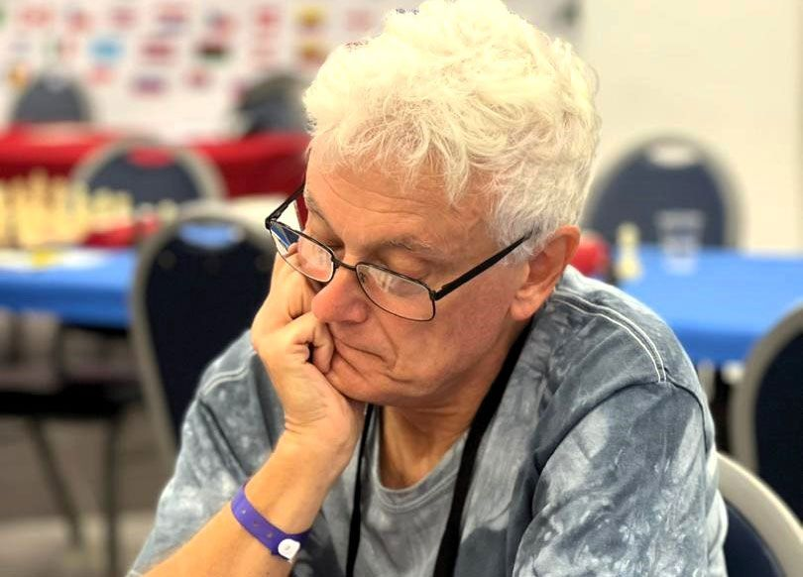
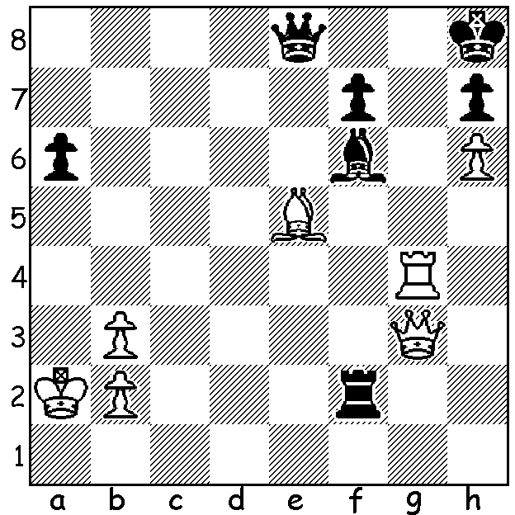

John Nunn vs Niaz Murshed 1985: John Nunn in Sicily
White mates in 4:

WORLD SENIOR CHAMPIONSHIPS
The 2023 World Senior Championships, played in Sicily recently, attracted about 270 entries across the Open 50+, the Open 65+ and the Womens 50+ categories. The winners were Michael Adams (UK) with 8.5/11 in tiebreak from Suat Atalik (Serbia) in the Open 50+, John Nunn (UK) with 8.5/11 in the Open 65+ in a tiebreak from Lubomir Ftacnik (Slovakia) in the Open 65+ and Monica Calzetta Ruiz (Spain) 8.5/11 in the Womens.

Michael Adams is an eight-times UK champions and was rated 4th in the world from 2000 to 2002. John Nunn is a three-times world champion in Chess Problem Solving, was UK champion in 1980 and at one time was ranked in the world’s top ten. He was also defending champion in this event. Although I have never met Adams, we did go to the same secondary school. Truro School in Cornwall, and I played in the same team as Nunn in the London League, Richmond and Twickenham. Nunn, a mathematics prodigy, also hails from Cornwall.

WHERE IS THE WORLD CHAMPION?
Ding Liren (China) has withdrawn from several events since becoming world champion in April and has not played in any tournament since May. He has recently revealed that an unspecified illness has been the cause of his absence from tournament play but that he intends to defend his world title next year as yet undecided location. However he has stated that he does not intend to have a long chess career.

SOLUTION: 1.Bxf6+ Rxf6 2.Re4 (deflection – 2…Qxe4 3.Qg7#) 2…Qf8 3.Re8+ (another deflection) 3…Qxe8 4.Qg7#.

