CHESS 6 April, 2024 David Ellis ellisd19@bigpond.com 043979860

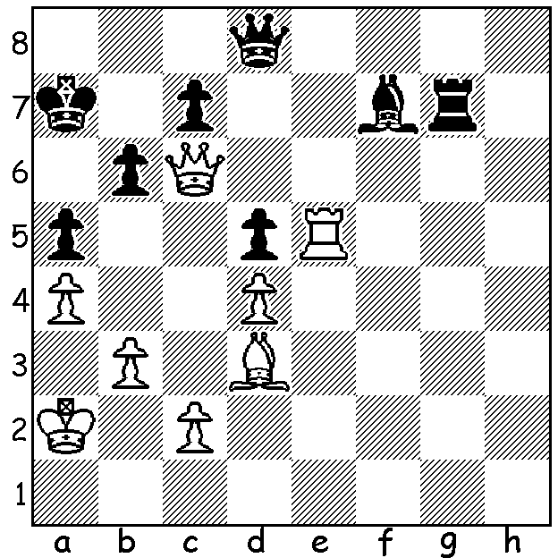

[DIAGRAM HERE]
Fabiano Caruana vs
Ruslan Ponamariov 2014
White to play and win (3 moves)

CANDIDATE VETERANS
Of the eight players in the Candidates Tournament (Toronto, April 3-22) three are players with more than one appearance in previous Candidates. Fabiano Caruana (USA) has played in all four tournaments between 2016 and 2022 while Hikaru Nakamura (USA) and Ian Nepomniachtchi (Russia) have both played in two.
Fabiano Caruana is 31 and ranked second in the world. Caruana is a three-times US champion. He won the Candidates in 2018 to challenge Magnus Carlsen for the world title. The 12 game match finished with every game drawn before Carlsen won all three games in Rapidplay to retain the title.
Aged 33, Ian Nepomniachtchi played in the 2021 and 2022 events winning both. His challenge to Carlsen in 2021ended in a heavy loss 3.5-7.5. However Carlsen declined to defend his title in 2023 resulting in a match for Nepo against Ding Liren (China), the Candidates runner-up. Their scheduled match finished level at 7-7. Then after three draws in Rapidplay Ding won the fourth to claim the title. Nepo has been Russaan champion twice.
The oldest player is Hikaru Nakamura at 36. He is ranked 3rd in the world and the only player who can hold his own against Carlsen in Rapidplay and Blitz. He is the most active and successful of the leading world players in online Blitz and Bullet Chess. He has been US champion five times.
Next week the remaining five players and the week after the results.

LONGEST EVER SPORTING EVENT
The 2020 Candidates played in Russia started 16 March 2020 and finished 27 April 2021. The eight-player event over 14 rounds was temporarily halted after 7 rounds on March 26 due to Covid restrictions before resuming over a year later with Nepo emerging as the winner.

SOLUTION: 1.Re7!! (deflection to remove queen from back rank) 1…Qxe7 2.Ba6 (a second deflection) 2…Kxa6 3.Qa8#.

