CHESS 20 April, 2024 David Ellis ellisd19@bigpond.com 043979860

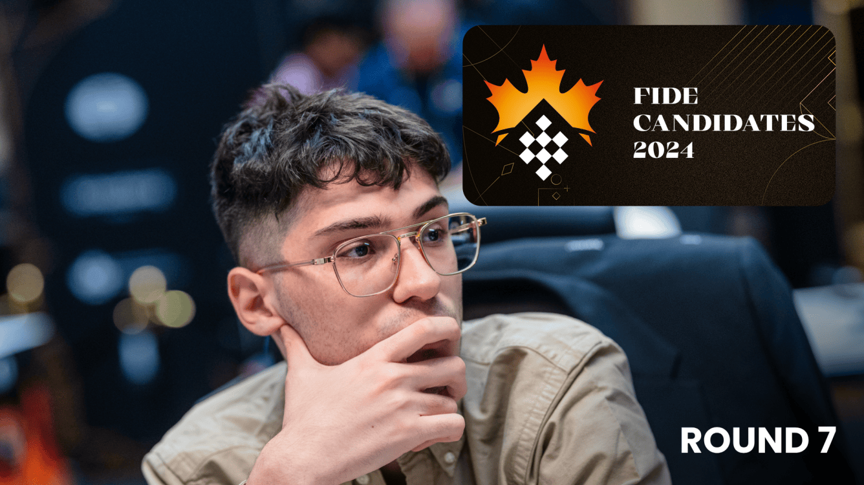
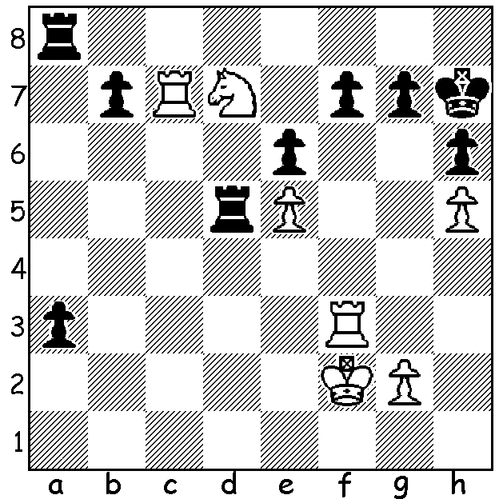

Alireza Firouzja vs Gukesh Firouzja
(Candidates 2024, Rd 7)
White to play: who will win?

SIX STILL IN RUNNING IN CANDIDATES
After 10 rounds the Candidates Tournament (Toronto, April 3-22) is nearing the end with most of the eight players very much in the running for top spot and a crack at Ding Liren’s world title. Ian Nepomniachtchi, winner of the previous two Candidates, is the only unbeaten player with 6pts (+2 =8), a score equalled by Gukesh (+3 =6 -1). Close behind are Praggnanandhaa, Fabiano Caruana on 5.5 (both +2 =7 -1) together with Hikaru Nakamura (+3 =5 -2) while Vidit is on 5 (+3 =4 -3). If Nepo wins he will be the first player to have won three Candidates. Previously Vassily Smyslov, Boris Spassky, Viktor Korchnoi and Anatoly Karpov have all won two Candidates. You can keep up to date on a number of sites including chess.com

CARLSEN WINS AGAIN
For the third time Magnus Carlsen has won the Grenke Classic in Karlsruhe, Germany, defeating Richard Rapport 1.5 – 0.5 in the final. The tournament, a six-player double round robin with finals was played at 45min + 10sec with two games a day. This is Carlsen’s sixth tournament win in a row while his successor as world champion Ding Liren came a disappointing 5th. In all over 2500 players competed in the various events with the Open won by Hans Niemann with 8/9. However the sensation of the event was =2nd by 12 year old Yagiz Esdogmus from Turkey (7.5) who is now the youngest current GM and the fourth youngest to attain the title.

SOLUTION: White ignores Black’s threat to queen with 1.Rxf7! If 1…a2 2.Nf6+ Kh8 3.Rxg7 a1=Q 4.Rh7#. Black played 1…Kh8 but after 2.Nf8 a2 3.Ng6+ Black resigned. If 1…Kg8 2.Nb6 a2 3.Rxg7+ Kh8 4.Rh7+ Kg8 5.Rcg7+ Kf8 6.Nxd5! a1=Q (if 6…exd5 7.Rh8+ Kxg7 8.Rxa8) 7.Rf7+ and mates. Black checks do not alter the outcome and 1…Rxd7 also fails to save Black. This was Gukesh’s only loss in Rounds 1-10.

