CHESS 27 April, 2024 David Ellis ellisd19@bigpond.com 043979860

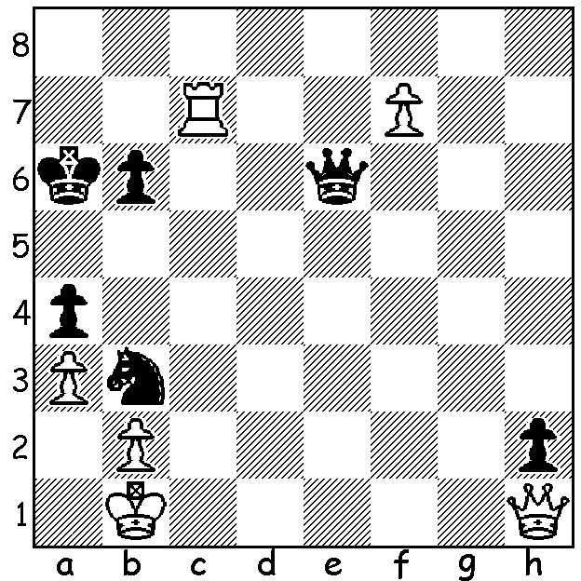

Fabiano Caruana vs
Ian Nepomniachtchi
(Candidates 2024, Rd 14)
Black has a surprise
drawing line.

Caruana (top & Nepo)

‘THE KIDS ARE TAKING OVER’
The heading is a pre-season quote by Eagles coach Adam Simpson and would be appropriate to the Candidates if expressed in the singular. In Round 12, with three rounds to go in an amazingly exciting Candidates four players, three well-established players and one teenager, were all in with a winning chance and the opportunity to challenge Ding Liren for the world title. Leader Ian Nepomniachtchi, winner of the previous two Candidates, drew his game with Nijat Abasov and was joined on 7.5 by Hikaru Nakamura and 17 year old Gukesh Dommaraju who both won their games while another previous Candidates winner Fabiano Caruana also won to be a mere half point behind.
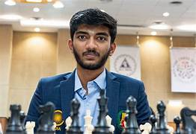
Round 13 saw Gukesh emerge as sole leader after
avenging an earlier loss to Alireza Firouzja. Nepo
vs Nakamura was drawn and they were joined in
second place by Caruana who defeated
Praggnanandhaa.
Round 14, the final round, had the dream pairing
of Nakamura vs Gukesh and Caruana vs Nepo.
Nakamura was unable to make any headway with
the game finishing with just kings while Caruana
with queen and rook against queen and knight Gukesh
missed a number of chances to win before conceding a draw after 109 moves (Q + a & b pawns vs Q + b pawn) leaving Gukesh the tournament winner.
Final scores: Gukesh 9/14, Nepo (the only unbeaten player), Nakamura, Caruana 8.5, Praggnanandhaa 7, Vidit 6, Firouzja 5, Abasov 3. Abasov failed to win a game, the second player to do so after Anish Giri drew all 14 games in 2016.

SOLUTION: 1…Nd2+ 2,Kc2 Qg6+!! 3.Kxd2 Qd6+ and although White can win the dangerous h pawn he cannot escape a perpetual check. Nepo missed this chance but in an endgame with a number of errors by both sides he still managed to draw the game.

