CHESS 04 May 2024 David Ellis ellisd19@bigpond.com 043979860

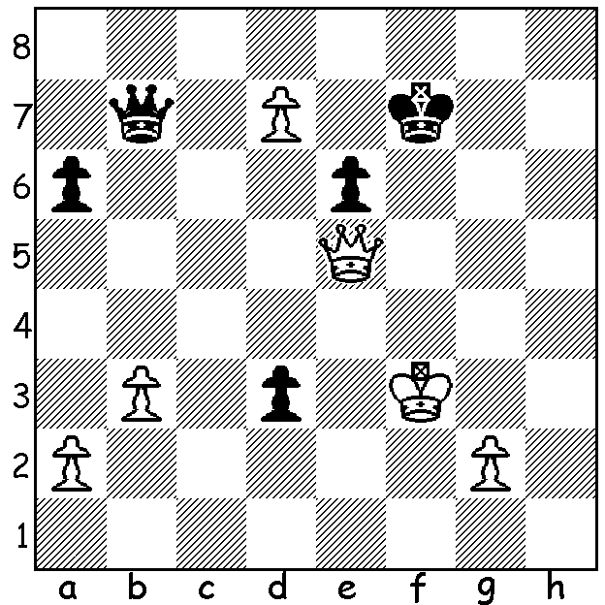

Vaishali Rameshbabu vs Pragg and sister Vaishali who
Alexsandra Goryachkina became a GM in December.
(Womens Candidates 2024)
White to play and win.

WOMENS CANDIDATES
The Womens Candidates was held simultaneously at the same venue in Toronto as the Open Candidates but unlike the latter did not have the same nail-biting finish with winner Tan Zhongyi (China), 9/14 (+5 =8 -1) leading throughout and finishing a point and a half ahead of Humpy Koneru (India), Lei Tingjie (China) and Vaishali Rameshbabu (India). Other scores: Russians Alexsandra Goryachkina 7 and Kateryna Lagno 6.5 (both playing under the FIDE flag), Nurgyul Salimova (Bulgaria) and Anna Muzychuk (Ukraine) 5.5. Tan (world champion 2017-18) now has a chance of revenge against present champion Ju Wenjun (China) who defeated her in their 2018 match 5.5-4.5. Vishali, the elder sister of Pragg who scored 7 in the Open Candidates, had the most decisive games, winning six and losing five. Muzychuk, who lost a close play-off to Tan in the 2017 Womens World Championship, was the only player not to win a game. Seven of the eight are GMs (Grandmasters) with the youngest, Salomova 20, an IM (International Master).

2024 OLYMPIAD
The 45th Chess Olympiad will be held in Budapest, Hungary, in September this year. Australia will be competing in both the Open and Women’s event. Australia’s top player will most likely be WA’s Temur Kuybokarov while Patrick Gong has also been nominated for selection. As there is no government assistance for this event, one of the largest sporting events in the world, the Australian Chess Federation is making an appeal for money to assist the players. Hopefully WA individuals and clubs will make contributions. The ACF will be matching donations, dollar for dollar, which can be sent to acfappeal.aunz.org

SOLUTION: 1.Qe4! If 1…Qxe4+ 2.Kxe4 Ke7 3.Kxd3 Kxd7 and White has a basic endgame win. If 1…Qxd7 2.Qh7+ Ke8 3.Qxd7+ Kxd7 4.Ke3 and again a winning king and pawn ending.

