CHESS 18 May 2024 David Ellis ellisd19@bigpond.com 043979860

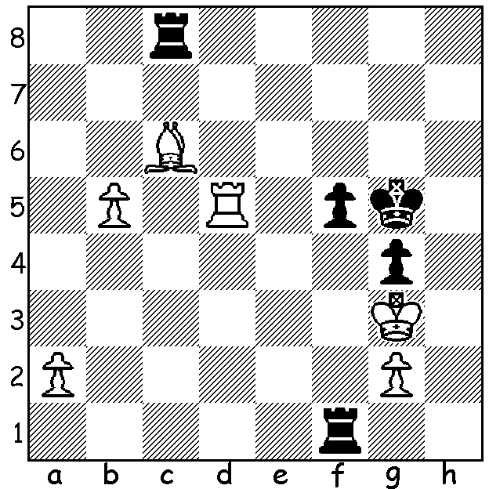

Frederick Dewhurst Yates
vs Jan Willem te Kolste, 1913:
Black wins brilliantly.

A LOOK BACK NEARLY 100 YEARS
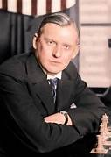
It’s always interesting to look back on major chess events of earlier years. One such event was the 1925 Baden-Baden Tournament (round robin with 21 competitors) which contained many of the world’s top players, though missing Jose Raul Capablanca and Emmanuel Lasker. It was a time when world champion Capablanca
seemed invincible but who might emerge to challenge him?
It was a time when Hypermodernism was emerging, led by
Richard Reti, where White would make no initial attempt
to control the centre (eg 1.Nf3 2.g3 or 2.b3). Winner of the
event with 16/20, and the only player not to lose a game, was
Alexander Alekhine, who was to defeat Capablanca to become
world champion in 1927. Second was Akiba Rubinstein with
14.5, followed by Friedrich Saemisch, Efim Bogoljubov,
Saveilly Tartakower and Frank Marshall with the leading
Hypermoderns Reti and Nimzovitsch finished midway with 11
and 10 respectively. The event was largely organised by
Siegbert Tarrasch, who had lost a world title match to Lasker
in 1908. Sadly Tarrasch was past his prime and scored only Alexander Alekhine
7.5. Of note was the score of Dutch master Jan Willem te Kolste, who could manage only three draws in his 20 games, finishing 4.5 points behind the next lowest, Sir George Thomas. However te Kolste’s career did have its successes, winning the Dutch Championship in 1907 and representing Netherlands in the 1927 London Chess Olympiad.

The WA Championship and WA Reserves Championship will be held from Friday 31st May to Monday 2nd June (7 rounds). For details of this event and entry see cawa.org.au

SOLUTION: 1…Rd8! (deflection to relieve the pin) 2.Rxd8 f4+ 3.Kh2 g3+ 4.Kh4 Rh1#. If 2.Re5 Rd3+ mates or wins bishop.

