CHESS 25 May 2024 David Ellis ellisd19@bigpond.com 043979860

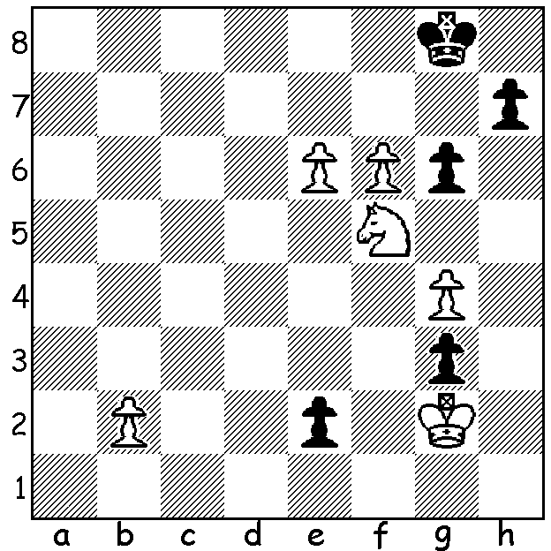

White to play and win
in this composition
(ACF Newsletter May 2024)

CARLSEN’S WINNING STREAK OVER
World Number 1 Magnus Carlsen took his successive tournament top places to seven with victory in the Superbet Rapid and Blitz held in Poland with ten of the world’s top players playing each other twice in both Rapid and Blitz. Wei Yi (China) was leader through most of the event and by the final day led Magnus by 2.5 points with nine Blitz games to play. Magnus, who won ten games in a row, finally emerged winner with 26/36 with Wei on 25.5, a winning score in some years. Gukesh Dommaraju, who will play Ding Liren for the world title later this year, finished last on 12.5
Then Magnus went into the final of the Champions Chess Tour Classic Chess.com, a Rapidplay event 10min + 2sec, starting with 56 players. He faced twenty year old Alireza Firouuzja (France) but after two draws and a win he missed a winning line in Game 4 in a double rook ending and ended up losing. He was unable to gain any advantage in the decisive Armageddon final game as White and in frustration resigned in a drawn ending with B+P for R. (White is given more time in Armageddon but must win).

ACF OLYMPIAD APPEAL: a reminder
that the Australian Chess Federation is
seeking donations to assist our men and
women with their travel to Budapest in
September to be among the 190 or so
countries to compete in the 45th Chess
Olympiad. Check out acfappeal.aunz.org

The WA CHAMPIONSHIP and WA RESERVES CHAMPIONSHIP will be held from Friday 31st May to Monday 2nd June (7 rounds). For details of this event and entry see cawa.org.au

SOLUTION: 1.e7 e1=Q 2.e8=Q+! Qxe8 3.f7+! Qxf7 (3…Kxf7 4.Nd6+) 4.Nh6+ Kg7 5.Nxf7 Kxf7 6.g5! Now White has a textbook win with the outside passed pawn (did its presence give you a clue?).

