CHESS 1 June 2024 David Ellis ellisd19@bigpond.com 043979860

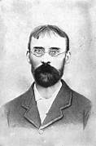
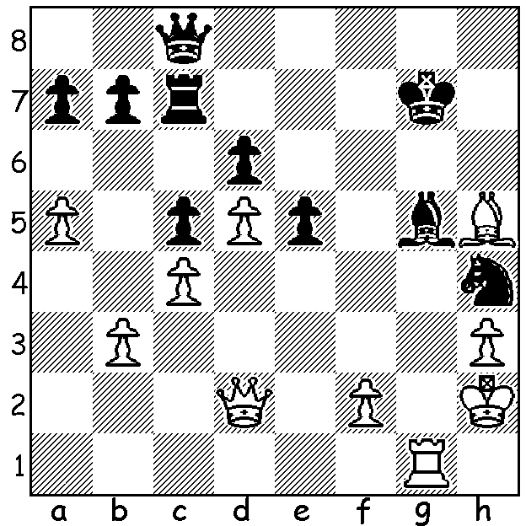

[DIAGRAM HERE]
Edmund MacDonald
vs Amos Burn, 1910
Black to play and reach
A winning position.

GREATEST MOVE EVER
Some time ago I came across a position where the winning move had been labelled the greatest move of all time. The move was played by British player Amos Burn (1848-1925), one of the world’s leading players at the end of the 19th century. He only learnt to play at the age of 16 but later took lessons from world champion to be Wilhelm Steinitz in London and like Steinitz became known for his defensive skills. Although an amateur, he had a long and successful playing career. His greatest successes were =1st in London 1887 ahead of Blackburne and Zukertort, 1st at Amsterdam 1889, 2nd Breslau 1889 and 1st at Cologne 1898. He also wrote regular chess articles for the magazine The Field from1913 until his death. His main opening legacy is the Burn Variation in the French, 1.e4 e6 2.d4 d5 3.Nc3 Nf6 4.Bg5 dxe.
A CHESS QUOTE
“One bad move can nullify forty good moves’ – Al Horowitz 1959 – and don’t we know it from experience!

WA BLITZ CHAMPIONSHIP
The WA Blitz Championship will be held at the State Library from 1-4pm on Sunday 9. Details cawa.org.au

SOLUTION: 1…Qg4!!! (this move, a brilliant interruption sacrifice, was the move described in the article). White has 3 ways to capture the queen – 2.hxg4 Nf3+ and 2.Bxg4 Bxd2 both leave White a piece down leaving 2.Rxg4 the only move. The game continued 2…Nf3+ 3.Kg2 Nxd2 4.Rxg5+ Kh6 h4 Nxb3 and Black’s queenside majority ensures the endgame win. The move has been compared to Frank Marshall’s …Qg6!!! vs Stefan Levitsky1912.

