CHESS 15 June 2024 David Ellis ellisd19@bigpond.com 043979860

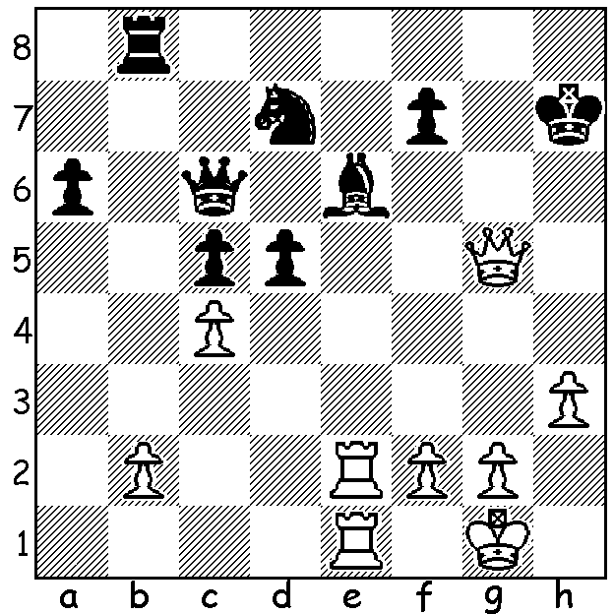
[DIAGRAM HERE]
Fabiano Caruana
vs Ding Liren
(Norway Chess 2024)
White to play and win.

NORWAY 2024
Norway Chess 2024, a double round robin played between six of the world’s top players with Armageddon games to be played in the event of a draw in Classic games, was won by world number 1 Magnus Carlsen, his 6th win since the onset of the event in 2113. In Classic chess he scored +3 =6 -1 and 5/6 in Armageddon, 17.5 in total. Second was Hikaru Nakamura, the only unbeaten player in Classic, and third Praggnanandhaa followed by Alireza Firouzja, Fabiano Caruana and in last place world champion Ding Liren. The Armageddon results made no difference to final placings but did provide some quick excitement to spectators, in the audience or online.

WEST AUSTRALIAN CHAMPIONSHIP
The West Australian Championships were played, probably for the first time, over a long weekend – 31 May to 3 June. The Championship, an eight-player round robin, produced a new winner, David Shen from New Zealand, with 6/7 (+5 =2). Second was Patrick Gong (5.5), winner on three previous occasions, with Rebo Fu third (5). The crucial game between Shen and Gong saw Gong sacrifice to attack Shen’s uncastled king but losing after being unable to find a winning continuation. The Reserves Championship with 32 players was won by Oscar Gao (6.5/7), followed by Derek Elkington (5.5), Dylan Gough and Nicola Vujasin (both 5).

SOLUTION: With his king exposed Black’s position seems untenable but his last move …Re8-b8 gives White an easy win – 1.Rxe6! resigns (1…fxe6 2.Qe7+ Kg8/h8 3.Rxe6 with a quick mate.

