CHESS 29 June 2024 David Ellis ellisd19@bigpond.com 043979860

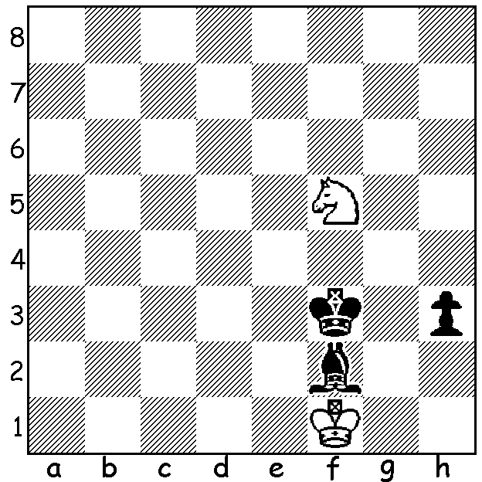

Alice Lee (pictured) vs Nana Dragnidze, Cairns Cup 2024:
Black’s last move 1…Bf2 covers key squares d4 & h4
but White can still draw. How?

CAIRNS CUP 2024
The Cairns Cup is an annual round robin chess tournament for leading female players held, not in Queensland, but in St Louis, Missouri. The name comes from Jeanne Cairns Sinquefield, co-founder of the St Louis with her husband Rex. (They have the Sinquefield Cup, part of the Grand Chess Tour, named after them.) Time Limit was 120 min + 30 secs a move and draws by agreement were not allowed.
Contestants were ten of the world’s leading female
players including former Womens World Champion
Tan Zhongji and three US players, eight times
Womens US Champion, forty year old Irina Krush,
last year’s winner Anna Zatonskih and fourteen year
old sensation Alice Lee. Competition was intense
with the possibility of a five-way tie for first place
after eight rounds. However a draw in the final
round secured Tan Zhongji top spot with 6/9 and
US$50,000, the largest ever prize for a female Tan Zhongji
player. Tan will next year face up against defender Ju Wenjun for the women’s world title. Second was Anna Muzychuck (5.5) who received $40,000 with others scores being - =3rd Marika Dronavalli, Nana Dragnidze, former Womens World Champion Mariya Muzychuk and Alexandra Kosteniuk (5), =7th Alice Lee and Irina Krush (4), 9th Elisabeth Paehtz (3.5), 10th Anna Zotonskih (2). Incidentally there was a down-under connection with Chief Arbiter (referee) being Australian Anastasia Sorokina.

SOLUTION: 1…Bf2 was in fact a blunder allowing 2.Nh4+! If 2…Bxh4 3.Kg1 draws as the king cannot be driven from h1 after …h2. If 2…Kg3/e3 3.Nf5+ Kf3 4.Nh4+=. If 2…Kg4 3.Kxf2 Kxh5 4.Kg1=. Had Black placed the bishop elsewhere on the long diagonal (c5 or b6) she would have won.

