CHESS 13 July 2024 David Ellis ellisd19@bigpond.com 043979860

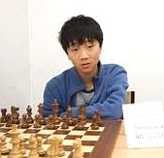
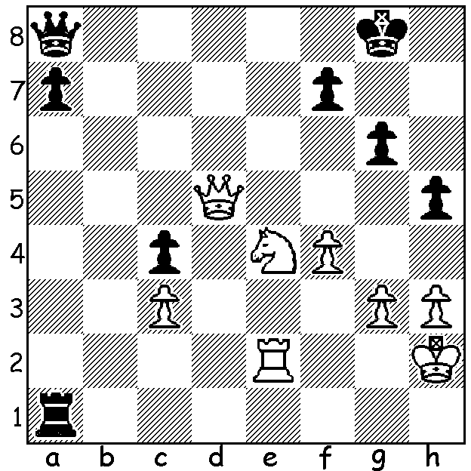

Michael Steadman vs Bobby Cheng (pictured), 2011
Black to play and win

WORLD CHAMPIONSHIP IN SINGAPORE

The Singapore Chess Federation has won the bid to host the 2024 World Championship Match to be played between November 20 and December 15 between defending champion Ding Liren from China and 18 year old Indian Dommaraju Gukesh who won the eight- player Toronto Candidates in April. Singapore, as a neutral country, was chosen over Indian cities New Delhi and Chennai but the site for the games has not yet been decided. The prize fund is US$2.5 million with the match being played over 14 rounds with tiebreaks if drawn 7-7.

AUSTRALIAN WOMEN BOUND FOR HUNGARY

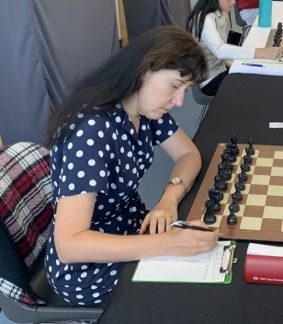
The Australian Women’s team for the 45th Olympiad
to be played in September this year in Budapest is:
Bd1.WGM (Women’s Grandmaster) Julia Ryjanova
who played in 2022 Chennai Olympiad and was
winner of Oceania Womens Champion in 2019 &
2013: 2. Jilin Zhang who played in the last two
Olympiads in Chennai, India, and Batuma, Georgia:
3.Giang Nguuyen, a veteran of seven Olympiads
who scored 6/9 in Chennai; 4.Zhiyuan Shen 5.Alaina
Vincent; non-playing captain IM Mihajlo Radovanic.

Julia Ryjanova

SOLUTION: Clearly Black loses after 1…Qxd5 2.Nf6+ / 3.Nxd5. However 1…Rh1+! (deflection) forces 2.Kxh1 allowing 2…Qxd5 and the queen is lost. (More Australian Olympiad players’ puzzles to come.)

