CHESS 20 July 2024 David Ellis ellisd19@bigpond.com 043979860

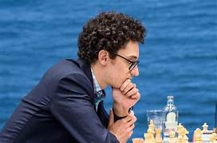
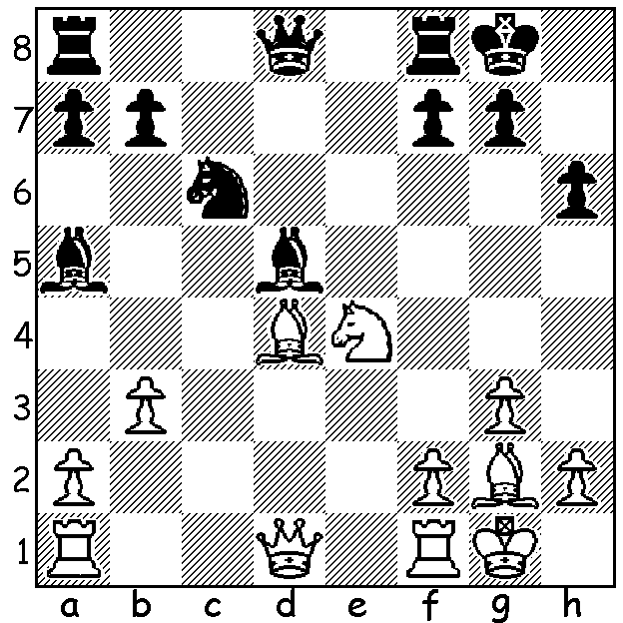

Fabiano Caruana (pictured) vs Alireza Firouzja, 2024
White plays a startling move to gain a strong
positional advantage (4 moves includes fork).

FABIANO WINS IN ROMANIA
The Grand Chess Tour is a series of events comprising three combined Rapid and Blitz tournaments and two Classic including the recently completed Classic in Bucharest, Romania, with nine top GMs together with leading Romanian player Bogdan-Daniel Deac. Despite draws by agreement not allowed 38 of the 45 games were drawn. However excitement built up in the final round with most of the field still in the running for top prize. Fabiano Caruana led nearly all the way but lost his only game in the last round to Anish Giri to finish equal first on 5/9 with Alireza Firouzja, and the two Indians Praggnanandhaa and Gukesh. Putting aside his last round disappointment, Fabiano won all three games in the Rapid Play-Off (10mins + 5sec) to take victory. Other scores: Ian Nepomniachtchi, Giri and Maxime Vachier-Lagrave 4.5, Wesley So and Nodirek Abdusattoriv 4, Deac 3.5.

TRAGEDY AT CHESS BOARD
Fifteen times Bangladesh champion GM Ziaur Rahman suffered a massive stroke during the 12th Round of the National Championship and died on the way to hospital. He was in second place at the time with 8/11. The country’s President described the death as ‘an irreparable loss to Sports’. Rahman’s son was also competing in the championship. He and his father were the first father and son to compete in the same team in the Olympiads (Chennai 2022).

TODAY IS INTERNATIONAL CHESS DAY
Today, 20 July, is International Chess Day, the day the World Chess Federation (FIDE) was founded in 1924. The day, which was proposed originally by UNESCO, has been celebrated since 1966.

SOLUTION: After Black’s very natural …Nc6 White unleashed 1.Bf6!! which breaks up Black’s pawns. There followed 1…gxf6 (best) 2.Qxd5! Qe7 (2…Qxd5 3.Nxf6+). White, with much the better position, went on to win. Position from the Rapid Play-Off in Bucharest.

