**CHESS** 14 Dec 2024 David Ellis ellis [d19@bigpond.com](mailto:d19@bigpond.com) 0439708607

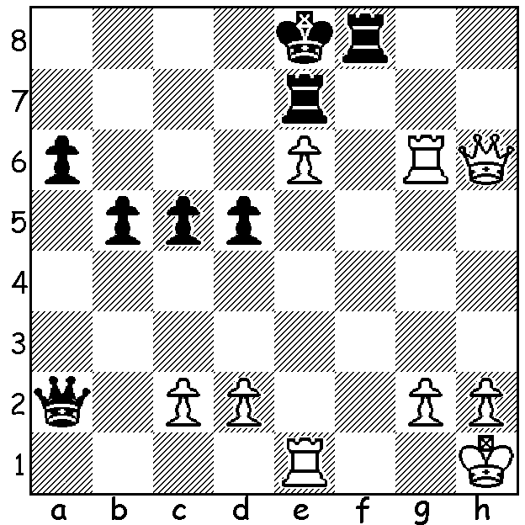

**Gawain Jones vs Loek Van Wely**

(London 2007)

White to play and

win (4 moves). *Competitors at London Classic 2024*

**ENGLISH VICTORY AT ARSENAL’S EMIRATES STADIUM**

No, I‘ve not suddenly become a reporter for English soccer. The reference is to the recent London Classic played 29th November to 7th December at the famous London football

ground. The field (pun intended) included four leading English players and four invited foreign GMs. Winner was Gawain Jones with 5/7 (+3 =4). Equal second were Indian Vidit Gujrathi, also unbeaten, Shakhriyar Mamedyarov (Azerbaijan), Nikita Vitiugov and Michael Adams (both UK) with 4, followed by Andrew Hong (USA) with 3.5, women’s world champion Ju Wenjun (China) with 2.5 and Shreyas Royal with 1. Earlier this year Royal became UK’s youngest ever GM at 15 years and 7 months. Previous winners at London include world champions Vishy Anand, Vladimir Kramnik, Ding Liren, Magnus Carlsen (4 times) as well as Wesley So, Hikaru Nakamura and Michael Adams.

It might be thought reading reports that

these leading tournaments are played in

isolation. However most major events

provide opportunities for all standards of

play. The London Classic also hosted a

ten-player tournament, the FIDE Masters,

for players striving to become GMs, a

nine-round Under 2000 rating with 77

players, a schools festival offering

hundreds of children the opportunity to

experience chess in a GM environment, as

well as GM simultaneous displays, variant-

chess tournaments, lectures and the Pro-Biz Cup in which business leaders are paired with GMs in a tournament where each pair makes alternative moves. And finally a fund-raising dinner at the famed Dorchester Hotel in Park Lane.

**SOLUTION:** 1.Qxf8+! Kxf8 2.Rf1+ Rf7 (2…Ke8 3.Rg8#) 3.Rxf7+ Ke8 4.Rg8#.