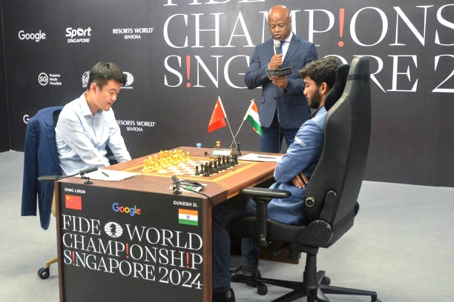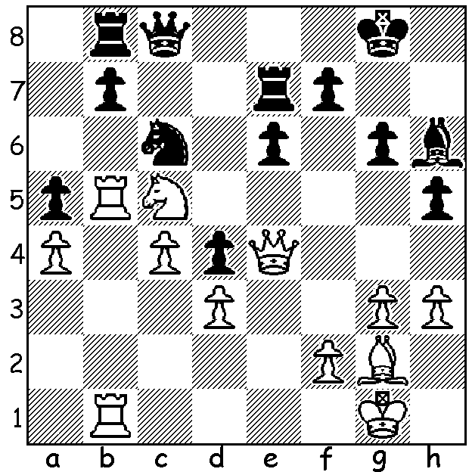

**Gukesh D vs Ding Liren**

(World Ch, 2024, Game 11); *Ding (White) vs Gukesh*

White to play and win.

**THE YOUNGEST WORLD CHAMPION**

The 14-game match for the world championship played in Singapore between champion Ding Liren (China) and Gukesh Dommaraju (India) was a very close affair with first one player then the other seemingly favoured to win. The match began with a win to the champion Ding playing the French Defence (1.e4 e6), a surprise choice as the French has been under the cloud for decades but it is played by Ding’s principal second, the Hungarian Richard Rapport. Gukesh equalised with a Queens Gambit in Game 3 and, after draws in Games 4-10, took the lead in Game 11 with the Reti Opening (Nf3 & c4). Ding countered immediately with a fine win in Game 12, another Reti, and after holding a difficult position in Game 13 (another French), Ding then seemed in the box seat with the White pieces for the final Classic game and considered the more likely winner in a Rapidplay play-off if the match finished 7-7. However it was Gukesh who gained the advantage in Game 14 winning a pawn. With rook, bishop and two pawns (neither passed) against rook, bishop and one pawn Gukesh seemed unlikely to win until Ding, after one inferior move, then blundered badly by exchanging rooks allowing Gukesh to then force off the bishops leaving a simple king and pawn ending win. Thus Gukesh became, at 18 years old, the youngest world champion (the 18th, extending back to Steinitz) and became India’s second world Champion after Viswanathan Anand (2007-13).

**SOLUTION:** Black is a pawn up but under severe pressure on the queenside. His last move, 1…Qc7-c8 (he needed to play 1…Nb4) defends against 2.Na6! but results in the immediate loss of a piece with 2.Qxc6! resigns (2…Qxc6 3.Rxb8 pinning the queen).