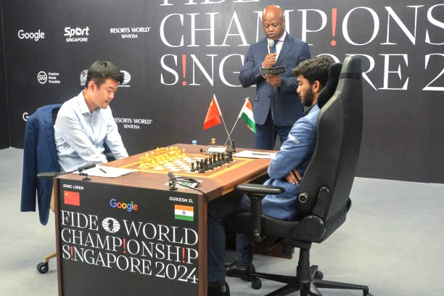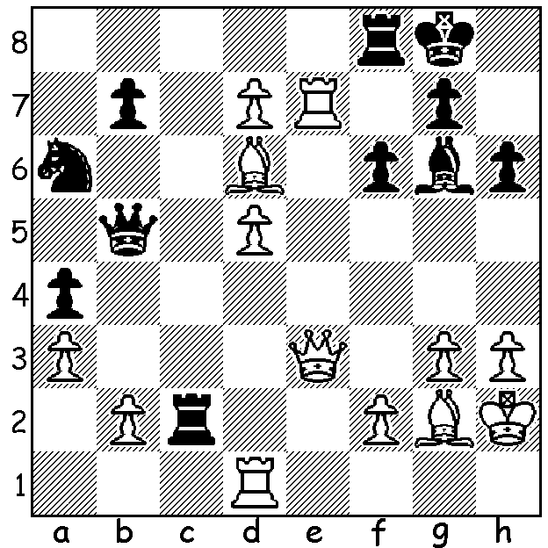

**Ding Liren vs Gukesh D** (World Ch, 2024, Game 12); White to play and win.

**THOUGHTS ON THE GUKESH – DING MATCH**

After Indian Gukesh Dommaraju took the world title from Ding Liren (China) by 7.5-6.5 in Singapore, many reviews have been written on the match. Here are a few thoughts.

The match between a teenager challenger and a champion coming into the match having shown few glimpses of his strength after a lay-off from the game, proved a very close, exciting match with Gukesh showing maturity well beyond his years in both play and temperament while Ding fought hard throughout, showing few signs of any mental problems that had plagued him after taking the title.

Analysts have claimed the standard of play has produced the highest ever level of accuracy for a world title match.

Both players rejected the most popular and well analysed openings in which games followed well known lines for 15-30 moves;

Gukesh was undoubtedly the better prepared with his team of eight (including two Indian GMs, Pentala Harikrishnan and former world champion Viswanathan Anand) while Ding was assisted by Hungarian GM Richard Rapport and Chinese national team captain Nia Hua. This superior preparation helped Gukesh gain considerable time advantage in most of the games as Ding spent long periods early in the games finding the best moves and often getting into severe time trouble. It is possible this contributed to Ding tiring and blundering in the final game after 633 moves over the 14 games in 18 days. One of Gukesh’s team was South African born Paddy Upton, a renowned mental sports coach, who has worked with international teams in rugby, cricket and hockey.

Two questions remaining; will Ding continue to play an important part in top-level chess and will Gukesh, who as a child, inspired by the success of Anand, had an early ambition to be world champion, improve further and be able to make successful defences to the world title?

**THE 2025 AUSTRALIAN JUNIOR CHAMPIONSHIPS** will be held at the Manning Community Centre, Manning, from 13th to 21st January. CAWA is seeking volunteers to assist in the running the event. If you can help for a few hours on any days please contact Andrew Hardegen [chessassociationwa@gmail.com](mailto:chessassociationwa@gmail.com) or 047421084

**SOLUTION:** 1.Rxg7+! resigns (1…Kxg7 2.Qe7+ Rf7 3.d8=Q+). Ding’s best game of the match.