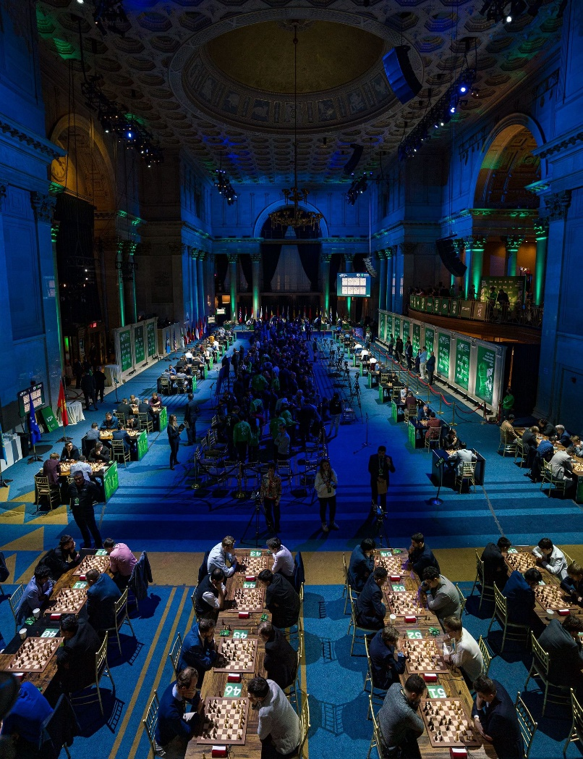

**Magnus Carlsen vs**

**Ruslan Ponomariov 2007;**

**White to play and win**

(3 moves)

*Playing arena, Wall Street*

**DID MAGNUS JUMP OR WAS HE PUSHED?**

2024 ended with the World Rapidplay and Blitz (26-31 December) being played in luxurious settings in Wall Street, New York with around 300 players registered to compete. However the play has been overshadowed by the dispute between world number 1 Magnus Carlsen, five times Rapid and seven times Blitz champion, and the chief arbiter of the tournaments, a dispute that was reported on in the West earlier this week. The dress code for the events stipulated that jeans were ‘explicitly prohibited’ and Carlsen, together with a number of others was fined, for him, a paltry $200 fine for wearing jeans and told to change for the next round (his hotel being a few minutes’ walk from the venue). Carlsen asked to be allowed to continue to play in jeans for the rest of the day, promising to dress appropriately the next day. This request was denied and he was forfeited for the following round with his reaction being to withdraw from the Rapid and the Blitz which was to follow. Ian Nepomniachtchi was also fined for wearing sports shoes but changed for his next game, The FIDE dress code, which has been in place for a number of years (though probably not strictly enforced), stipulates players should ‘dress professional or business casual … to create a positive and inspiring image for chess’ and FIDE emphatically supported the action of the arbiter. Carlsen had started badly scoring 2.5/5 on the first day with only one win before progressing to 5/8 before his withdrawal. Interestingly the Freestyle (Fischer Random) tournaments, which Carlsen is actively supporting, demand stricter dress codes with jackets showing the sponsors’ insignia being mandatory. Opinion seems divided on the issue, some believing Carlsen should have complied, others that the arbiter should have been a little more flexible. So what do you think? While Carlsen said emphatically that he would not play in the Blitz, he then changed his mind and agreed to play wearing jeans.

**THE 2025 AUSTRALIAN JUNIOR CHAMPIONSHIPS** will be held at the Manning Community Centre, Manning, from 13th to 21st January. CAWA is seeking volunteers to assist in the running the event. If you can help for a few hours on any days please contact Andrew Hardegen [chessassociationwa@gmail.com](mailto:chessassociationwa@gmail.com) or 047421084

**SOLUTION:** With his knight pinned and attacked three times, White wins with 1.Ne4! Rxd5 2.Nxf6+ Kg7 3.Nxd5.