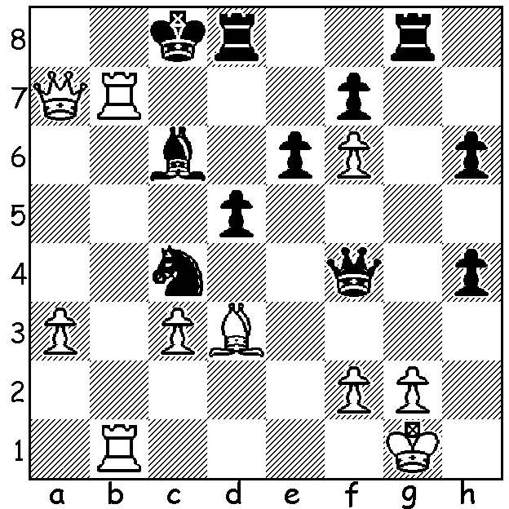

**Magnus Carlsen vs**

**Ian Nepomniachtchi**

(World Blitz final 2024)

White has sacrificed

to break through but

it is Black who mates

(move 2 is the !!)

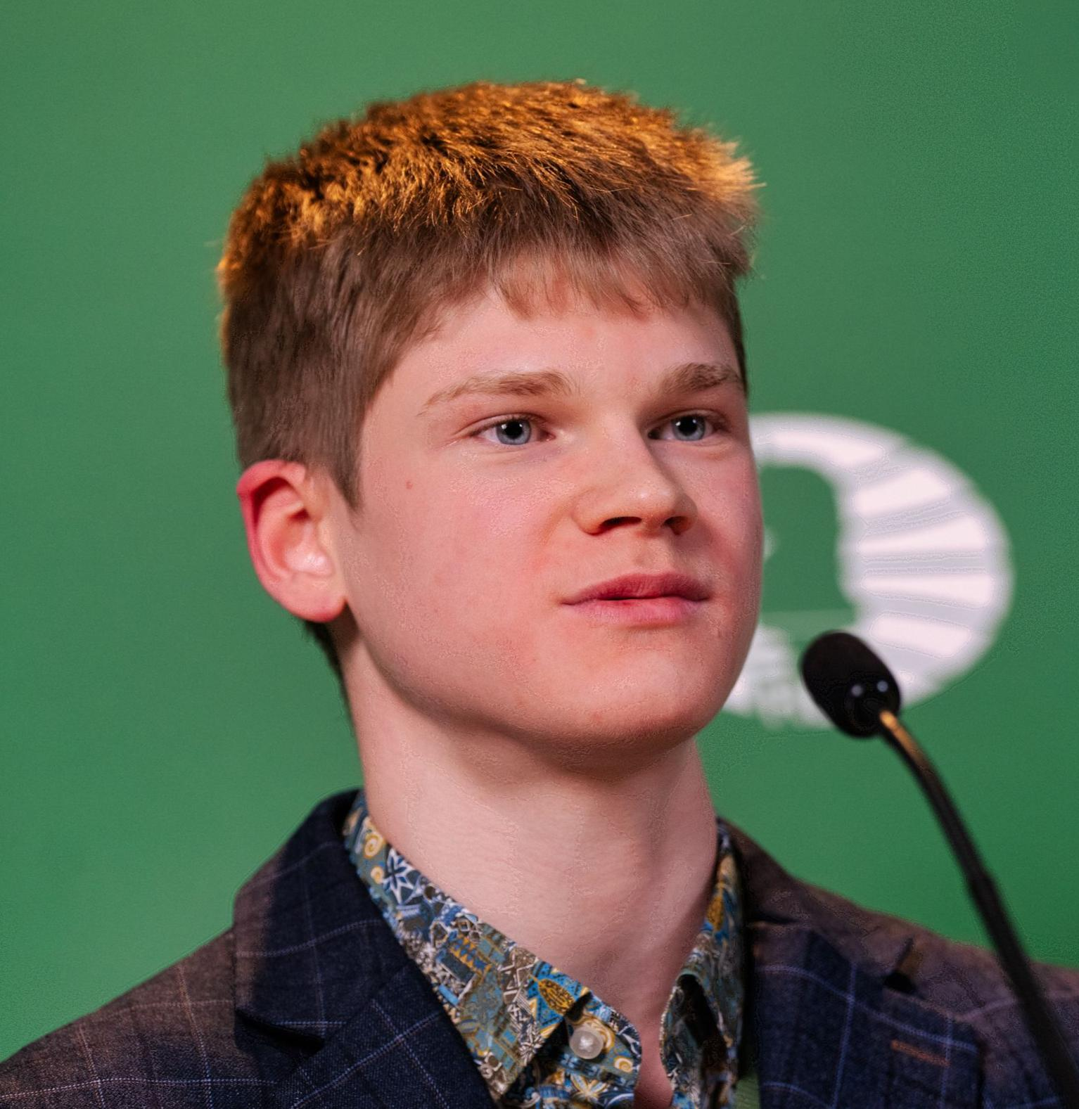**SURPRISE WINNER AT WORLD RAPIDPLAY**

After the withdrawal of Magnus Carlsen over a dress code dispute

a surprise winner emerged in the **2024 World Rapidplay** (15min +

10sec), played in the former home of the NY Stock Exchange,

Wall Street. Most of the top GMs fared badly, losing rating points

with Wesley So the worst, losing 28.4. The surprise winner was 18

year old Russian **Volodar Murzin** who went through undefeated

with 10/13. Murzin, who earned US$90,000, is the second youngest

winner after Uzbek Nodirbek Abdusattorov in 2021. Equal second

on 9.5 were two more Russians, Alexander Grischuk and Ian

Nepomniachtchi.

*Volodar Murzin*

**MAGNUS CREATES ANOTHER CONTROVERSY**

The **World Blitz** (3mins + 2sec) had a different format to previous years with the eight top scorers from a Swiss progressing to a knockout stage. The Swiss finished with 10 players level on 9.5/13 with Daniel Naroditsky (USA) and Daniil Dubov (Russia) the unlucky players eliminated on tie-break rules. In the quarter-final **Nepo** defeated new Rapid champion Volodar Murzin 2.5-0.5, Wesley So (USA) defeated Alireza Firouzja 3-1, Jan-Krzysztof Duda (Poland) defeated Fabiano Caruana 2.5-0.5 and **Magnus Carlsen** (Norway), after falling behind, defeated Hans Niemann (USA) 2.5-1.5. Readers will be aware of the animosity between Carlsen and Niemann after Magnus accused Niemann of cheating. In the semis Nep defeated So 3-2 and Carlsen defeated Duda 3-0. The final saw **Nepo** lose the first two games before winning the next two on demand. The players then played a succession of draws before requesting the arbiter to allow the sharing of the championship with the score 3.5-3.5. This was allowed after discussion with **Carlsen** once more stirring up controversy with the chess world divided on whether it was right to have joint winners.

**THE 2025 AUSTRALIAN JUNIOR CHAMPIONSHIPS** will be held at the Manning Community Centre, Manning, from 13th to 21st January. CAWA is seeking volunteers to assist in the running the event. If you can help for a few hours on any days please contact Andrew Hardegen [chessassociationwa@gmail.com](mailto:chessassociationwa@gmail.com) or 047421084

**SOLUTION:** faced with the threat of mate (Rb8+), Black unleashes 1…Rxg2+!! 2.Kxg2 (if 2.Kf1 Rxf2+! 3.Qxf2 Qxf2+ 4.Kxf2 Bxb7 and Black remains a piece up) 2…Ne3+!! opening the f file, White resigns (3.fxe3 – 2.Qxe3 d4+- 3…Rg8+ 4.Kh1 Qf3+ 5.Kh2 Qg2#). Interestingly the game followed the line in the French, Steinitz Variation, played successfully by Ding in his match vs Gukesh.