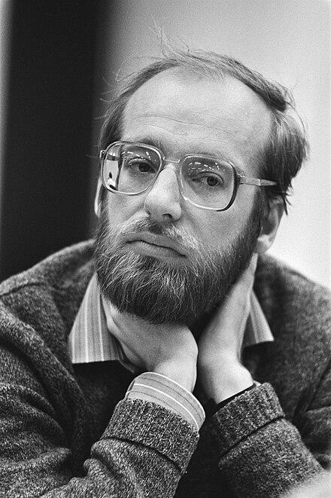

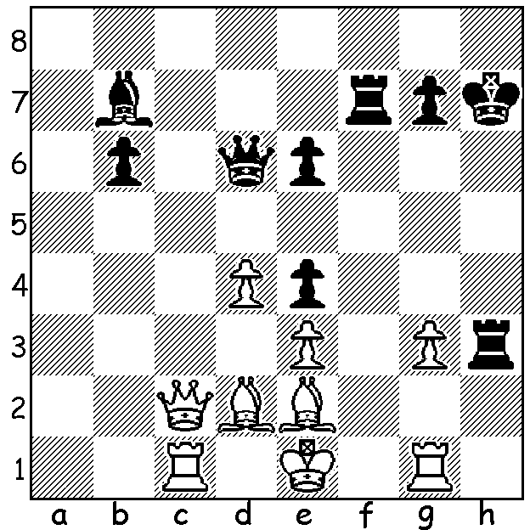

**Lajos Portisch vs**

**Robert Huebner, 1978**

Black to play & win. *Robert Huebner 1983*

**DEATH OF FORMER WORLD NUMBER THREE**

Robert Huebner, who was at one time ranked third in the world, died on January 5, aged 76. A winner of a host of international tournaments, he is considered the best German player since Emanuel Lasker, world champion from 1894 to 1920. He qualified and competed in four World Championship Candidates tournaments and represented Germany at 11 Olympiads with a 80.50% record from 122 games (Board 1 gold medal at 1972 Skopje Olympiad with +12 =6 -0). His most successful period was through the 1970s and 1980s, coming =2nd behind Bobby Fischer in the Palma Interzonal qualifying him for the Candidates, tied for 1st place with Tigran Petrosian and Lajos Portisch in the 1979 Rio de Janeiro Interzonal and then being ranked 3rd in the world behind Anatoly Karpov and Viktor Korchnoi. He had the unique misfortune to be eliminated in the 1983 Candidates KO tournament in Velden, Austria. Paired against former world champion Vassily Smyslov in the quarter-final and with the score 5-5 he lost on the spin of a roulette wheel at the local casino. He was undoubtedly a genius; he spoke 22 languages and was a meticulous and brilliant annotator of games (before the time of computer analysis). His collection of 25 games had 400 pages and he even published a book of his losses. His most famous sayings are, ‘Those who say that they understand Chess understand nothing’ and ‘You can always make it difficult for an opponent no matter how lost you are’.

**THE 2025 AUSTRALIAN JUNIOR CHAMPIONSHIPS** are being held at the Manning Community Centre, Manning, from 13th to 21st January. Nearly 300 players from all over Australia have entered in groups of Under 18 &16, Under 14 & 12, Under 10 & 8 in both Open and Girls.

**SOLUTION:**. 1…Qxg3+!! White resigns (2.Rxg3 Rh1+ 3.Rg1 Rxg1+ 4.Bf1 Rgxf1+ 5.Ke2 R7f2#). This is the first of a number of Huebner’s wins.