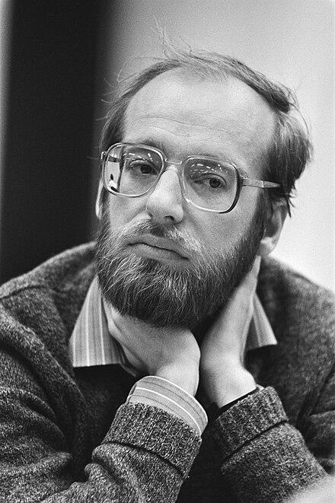

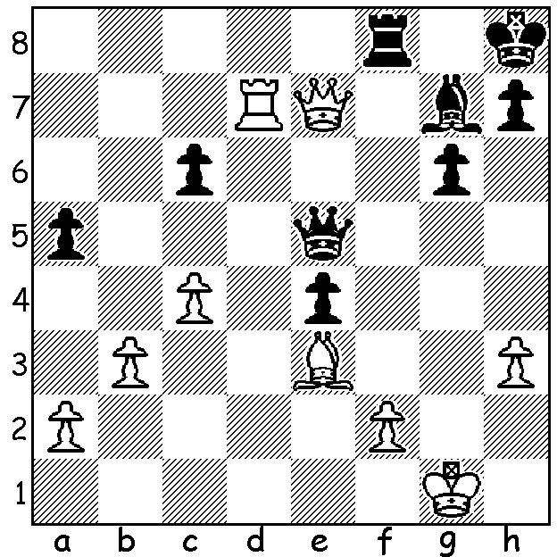

Another **Robert Huebner** win;

White to play and win

vs **John Nunn** 1981

(3 moves).

**OVERCOMING CHILDHOOD ADVERSITY**

I recently read an article in chess.com about 18-year-old **Voladar Murzin**, the surprise winner of

the 2025 World Rapidplay Championship. He gave some harrowing details about his early life

****in a home with an abusive father. He was beaten constantly from

the age of seven and also witnessed beatings administered to his

mother and sisters. His father, aware of his son’s talent, would often

make him play into the early hours, exhausting the child. When he

was eleven the family escaped the violence, fleeing 1700km east

from their hometown to Moscow. The family’s first apartment was

without beds with the purchase of mattresses to sleep on the floor

draining their savings. Money was very short and frequently there

was very little to eat. His father took out a travel ban on Voladar

when his son was trying to achieve his final GM norm, a ban that

was fortunately overturned after a court appeal enabling Voladar

to gain his GM title in 2022. Voladar, together with Andrey Espenko (rated World No 31) is one

of the few young hopes of Russia, the former dominant nation in chess, now with only one player, Ian Nepomniachtchi, ranked in the top 25.

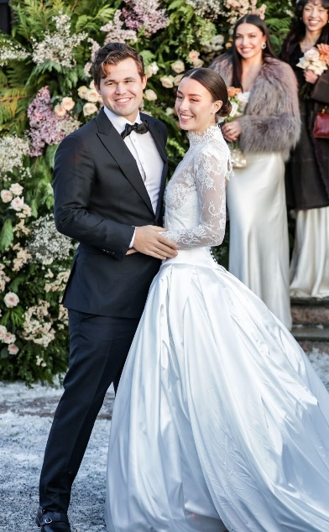

**MAGNUS GETS MARRIED**

World Number 1 **Magnus Carlsen** was married in Oslo on January

4 to 26-year-old Ella Victoria Malone in front of family and friends.

His wife was born to a Norwegian mother and an American father.

She studied in US and has spent years living in Singapore. The

couple first appeared together in public at the Freestyle tournament

in Germany early last year. Ella is said to have played a crucial

role in securing Magnus a lucrative deal as a model with fashion

brand G-Star Raw. Within a week of the nuptials Magnus was back

to work, playing in the Chess Bundesliga, Germany, a round-robin

for 16 teams each with eight players per round, with Magnus,

playing Bd 1 for soccer team St Pauli, winning his first game.

**SOLUTION:** 1.Qxf8+! (deflection) 1…Bxf8 2.Bd4 (pin) and the rook vs bishop ending is decisive.