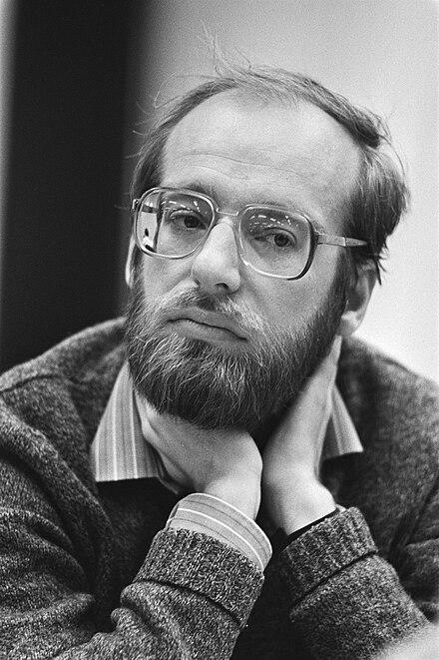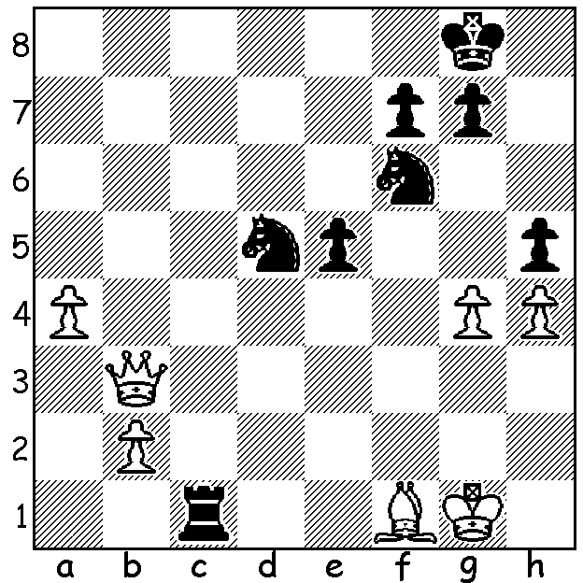

Another **Robert Huebner** win;

Black to play and win

v **Borislav Ivkov** 1970

**FIDE vs FCPC**

I expect almost all readers will be flummoxed by the heading. While most will know **FIDE**, the International Chess Federation (Federation Internationale des Echecs), few will recognise **FCPC**. It is the Freestyle Chess Players Club, a recently formed group to promote Freestyle Chess (Fischer Random or 960 Chess) in which pieces are arranged randomly behind the pawns (Black still mirrors White). The organisation is run by multi- millionaire **Jan Henric Buettner** and was co-founded by

**Magnus Carlsen** (we just can’t keep Magnus out of the news). Buettner had bought and converted

an old run-down Baltic sea village, Weissenhaus, Germany, into a luxury hotel complex which in

February last year was the setting for the first

tournament of Freestyle Chess with Classical

time limits with eight of the world’s top players

competing. After the undoubted success of this

venture plans were put in place to play a series

of such events spread over six continents with

prizes to be shared among all the group ($12

million already raised). All players with ratings

above 2725, 25 in number, were invited to compete

and they are joined by Vladimir Fedoseev who

won a series of qualifying games and matches.

The first event in 2025 is in Weissenhaus this

month with plans to play further tournaments in *Carlsen,2024 winner in Weissenhaus*

Paris, New York, Colombia, Delhi, Cape Town *with Buettner*

and Australia (in 2026). One would have hoped FIDE would endorse the concept but it is threatening legal action to contest calling the Freestyle series a World Championship claiming only FIDE can authorise world championships and warning that any unresolved conflict with FCPC might cause a split within chess ranks as did the Kasparov-Short decision to form the PCS (Professional Chess Association) in 1993. FIDE had previously run Fischer Random World Championships in 2019 (winner Wesley So) and 2022 (winner Hikaru Nakamura) but these were with rapidplay time limits.

**LOCAL PLAYER BECOMES AUSTRALIAN CHAMPION**

Congratulations to **Rui Gen Teh** in winning the **Australian Junior Championship** held at the Manning Community Hall last month with a score of 7/9. More next week.

**SOLUTION:** 1…Nxg4!! If 2.Qxd5 Rxf1+! 3.Kxf1 Ne3+ / 4…Nxf1 wins; if 2.a5 Nde3 3.Qb5 (3.a6

Rxf8#) 3…Nxf1 4.Qxf1 Rxf1+ 5.Kxf1 Ne3+ & the knight can stop the a pawn.