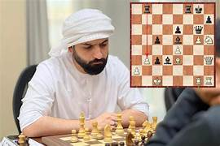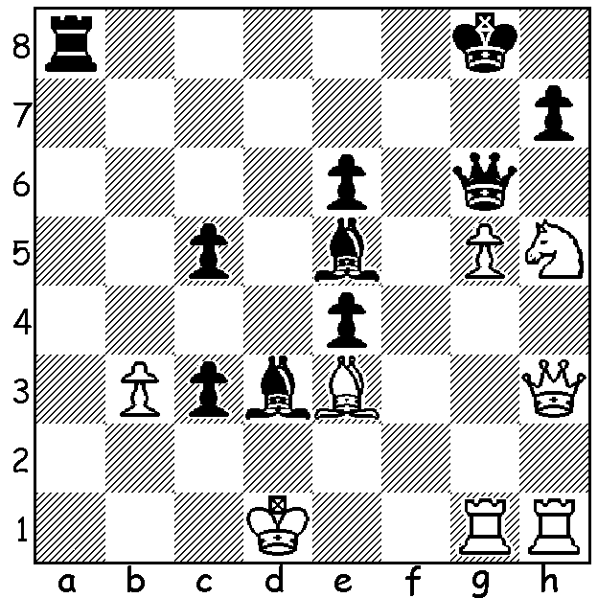

**Vladimir Fedeseev** *Salem Saleh*

**vs Salem Saleh 2024**

Black to play and mate in 9.

**KUYBOKAROV WINS IN MELBOURNE**

Perth player **Temur Kuybokarov**, a former Australian and Australian Open champion, has won the **Oceania Zonal**, a stepping stone to finding the next challenger for the world title, won last year by 18 year old Indian Gukesh Dommaraju. Temur finished with 8/9 (+8, -1) in a tournament held in Melbourne last month. He was followed by Australian international James Morris, Australian Champion Rishi Sardana & Sterling Bayaca, all on 7/9. A number of other West Australians were also competing – Ashvin Balavignan & Daniel Shen (5), Australian Junior Champion Rui Gen Teh (4.5), Neville Shah (4) as well as Kobe Wu (4.5) in the Womens’ Zonal which was won by Womens Grandmaster Julia Ryjanova with 8.5/9.

**AUSTRALIAN JUNIOR CHAMPIONSHIPS**

As reported last week local player **Rui Gen Teh** won the **Australian Junior Championship** held at the Manning Community Hall last month with a score of 7/9. In all there were nearly 300 entries (230 boys, 61 girls) with prizes in 12 divisions Under 18, 16, 14, 12, 10. 8 in both Open and Girl

Groups with Athena -Malar Retnaraja (SA) winning the Girls’ title with 7/9. Other West Australians who performed well were: Under 18 Open – Ashvin Balavignan 6/9, Shanon Koh 5; Under 16 Open - Issa Majidi 5.5/9, Barath Harirajesh and Liam Raptis 4.5; Under 14 Open – Eamon Harris 5/9; Under 12 Open – Uudamkhishig Togmol 6.5, Leo Gong 5.5; Under 10 Open - Ho Gia Buo 6.5/9, Le Quang Minh 6; Under 8 Open - Daniel Luong 5.5/9; Open Girls – Kobe Wu 4.5; Under 12/14 Girls – Senudi De Vas & Nithuli Liyanage 5/9: Under 10/8 Girls – Alexandra Fleming 4/8 who also scored 5/9 in Under 10 Open. Interesting is the preponderance of Chinese and Indian names, mirroring the 2024 World Championship between Ding Liren and Gukesh, Thanks to CAWA President Andrew Hardegen and all his helpers in the operation of this very successful project.

WA had also hosted the **Australian Schools Championships** at Duncraig Senior High in December with both Open and Girls’ championships in Secondary and Primary with Queensland teams coming away with top places in all four groups. WA schools competing were Rossmoyne Senior High and Perth Modern (Sec Open), Presbyterian Ladies College (Sec Girls), Oberthur (Pr Open) & Dalkeith (Pr Girls).

**SOLUTION**: 1…Qxh5+!! 2.Qxh5 Ra1+ 3.Bc1 Rxc1+! White resigns – 4.Kxc1 Bf4+ 5.Kd1 c2+ 6.Ke1 c1=Q+ 7.Kf2 (7.Qd1 Qe3+ 8.Qe2 Qxe2#) 7…Qe3+8.Kg2 Qg3#. I recommend readers to look up this amazing game which was chosen by chess.com as Game of 2024.