**CHESS** Feb 15, 2025 David Ellis [ellisd10@bigpond.com](mailto:ellisd10@bigpond.com) 0439798607

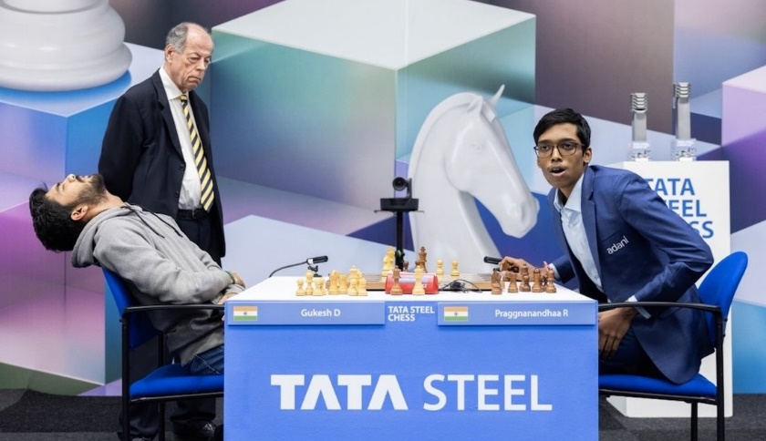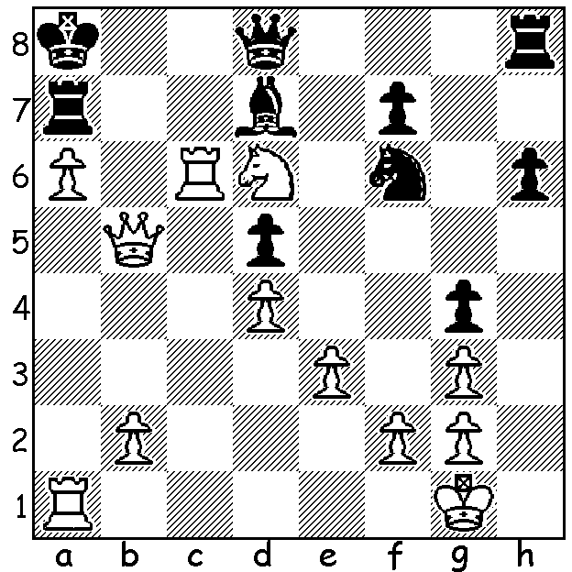

**Praggnanandhaa vs**

**Alexy Sarana** *Pragg defeats Gukesh in Tata Steel Final*

**(Tata Steel 2025)**

White to play and win:

**TATA STEEL TRIUMPH FOR INDIA**

Wijk aan Zee in the Netherlands has hosted an annual Chess tournament since 1938 which has undergone a number of name changes before becoming the Tata Steel Tournament in 2001. From small beginnings it has developed into one of the premier events of the year and has been described as ‘the Wimbledon of Chess’ with its winners including many of the world champions from Max Euwe to Magnus Carlsen. Besides the elite group, thousands travel to take part in the various events each year (this year Jan 18 – Feb 3). The main 2025 event was a 14 player round robin headed by world champion Gukesh and including former winners Wei Yi (China), Fabiano Caruana (USA), Anish Giri and Jorden van Foreest (Netherlands). The final round saw world champion Gukesh and fellow Indian Praggnanandhaa leading with Nodirbek Abdusattorov (Uzbekistan) a point behind. Surprisingly both leaders lost their final game, Gukesh to another Indian Arjun Erigaisi while Vincent Keymer (Germany) ground out a 80 move win against Pragg. With Abdusattorov unable to catch to catch the two leaders with a draw against Pentala Harikrishna, a two-game Blitz play-off was required to find the winner. Gukesh won the first but blundered in the second. Finally a sudden death Blitz game was played (White 2min 30sec + 2 sec, Black 3min + 2sec) with Gukesh (Black) pressing but going astray and losing a knight ending. The results, as well as emphasising the power of India, were possibly a sign that the young are taking over with Gukesh 18, Pragg 19 and Abdusattorov 20.

**SOLUTION**: White, a piece down and with his rook on c6 pinned, unleashes 1.Qb7+! and Black resigns (1…Rxb7 2.axb7+ Kb8 3.Ra8#). Alexy Sarana, 25, is a Russian player with a Ukranian father who lives near Kyiv. Alexy moved to live in Serbia in 2023 and stated he would only consider returning to Russia once the Russians withdrew from Ukraine. His main achievement has been winning the European Championship in 2023.