**CHESS** Feb 22, 2025 David Ellis [ellisd10@bigpond.com](mailto:ellisd10@bigpond.com) 0439798607

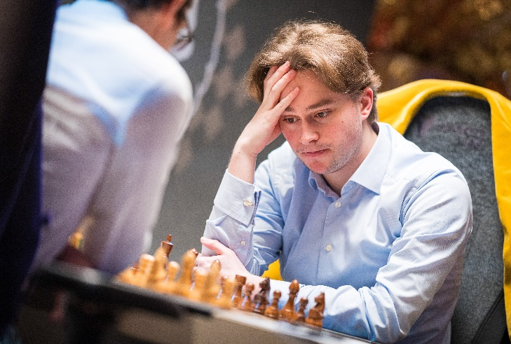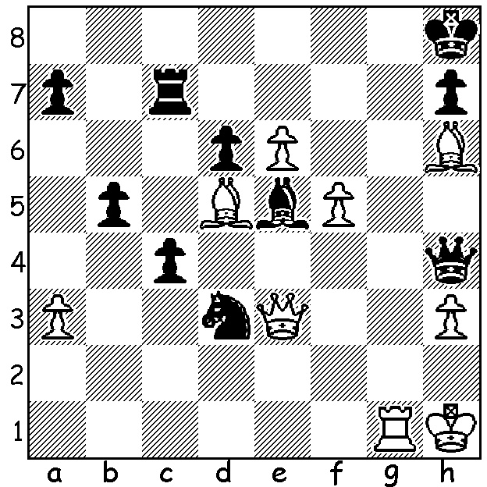

**Vincent Keymer vs**

**Allan Stig Rasmussin 2018**  *Keymer vs Caruana*White has a mate in 3  *(Freestyle Final, Feb 2025)*

and a mate in 4.

Can you find both?

**YOUNG GERMAN WINS FIRST FREESTYLE**

The first of the Freestyle Grand Slam events, played in the Weissenhaus resort of backer multimillionaire Jan Henric Buettner from 7th to 14 February, was won by twenty-year-old German Vincent Keymer who won the first, then drew the second game against Fabiano Caruana in the Final. The tournament comprised a ten-player Rapidplay round robin followed by a two-game knock out with Classic time controls for the top eight players. Freestyle, also called Fischer Random or 960 Chess, has the pieces on the back ranks randomised at the start with Black mirroring White as in normal chess. Knockout results; Quarterfinals - Keymer def Alireza Firouzja 1.5-0.5, Magnus Carlsen def Nodirbek Abdusattorov 2-0, Javokhir Sindarov def Hikaru Nakamura 2.5-1.5 (rapid play-off required), Caruana def world champion Gukesh 2-0; Semifinal – Keymer def Carlsen 1.5-0.5, Caruana def Sindarov 4-3 (after Rapid, Blitz & Armageddon). Losers in each round played off for final positions and prizes as did the two eliminated players, Levon Aronian and Vladimir Fedoseev. Keymer, Germany’s top player, who gained entry as a player from the host country, earned $200,000 for his success. Originally the Grand Slam was to be called the Freestyle World Championship but this was renamed after FIDE stated it alone had the right to run or sanction World Championships. The next of the five 2025 Freestyle Grand Slam events will be played in Paris from 8th to 15th of April. Buettner has, without consulting Carlsen, invited Hans Niemann to compete as a wild card entrant. Knowing the hostility between Carlsen and Niemann, Niemann’s inclusion seems designed to increase interest among the public.

**SOLUTION**: 1.Rg8+! Kxg8 2.e7+ Kh8 3.e8=Q# and 1.Qxe5+! Nxe5 2.Bg7+ Kg8 3.e7+ Nf7 4.e8=Q#.