**CHESS** March 1, 2025 David Ellis [ellisd10@bigpond.com](mailto:ellisd10@bigpond.com) 0439798607

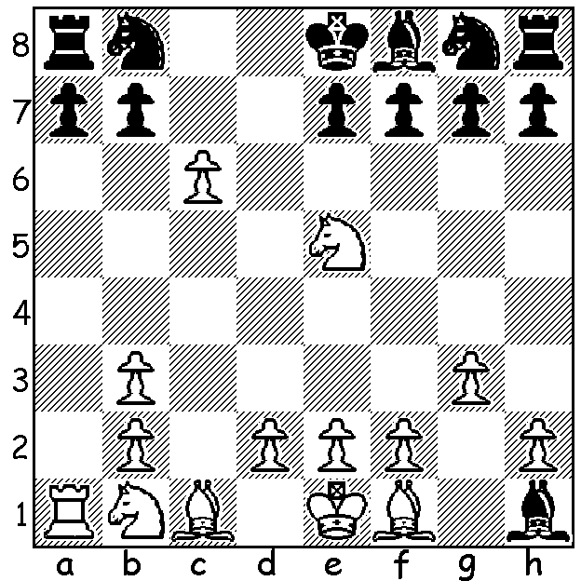

**Fabiano Caruana vs** *Caruana (L) vs Firouzja*

**Alireza Firouzja 2024:**

after White’s next move

(his 9th) Black resigns. Why?

**A FAB MINIATURE**

It’s virtually unknown for a Grandmaster to lose a game in less than ten moves but it happened last year in the CrunchLabs Masters, a 10min + 2sec Knock-Out event in a game between super-GMs Caruana and Firouzja. Despite this loss Firouzja won the mini-match 3-2 against Caruana, then defeated Jan Krzysztof Duda in the semifinal before losing to Maxime Vachier-Lagrave in the final. It seems the trap was known – but evidently not by Firouzja! Here are the moves;

**Fabiano Caruana – Alireza Firouzja**

1.c4 c6 2.Nf3 d5 3.g3 Bg4 4.Ne5 Bf5

5.Qb3 Qb6 6.cxd5 Qxb3 7.axb3 Be4? 8.dxc6 Bxh1?

**LOCAL NEWS: NEW CHESS CLUB:** a new chess club has started up in Padbury, the West Coast CC which meets at 7pm on Thursdays at Gibson Hall. Players of any standard welcome. Contact: Dylan Gough [chessnut36@gmail.com](mailto:chessnut36@gmail.com)

**CAWA NEWSLETTER:** CAWA puts out regular newsletters which contain all the chess news in the West. It also contains chess puzzles and a chess crossword created by newsletter editor Mike McGregor who is very much a cryptic crossword ace. One clue from February’s edition (which I have amended); Sounds like an angler and a policeman dethroned a champion (2 words, 5 & 7 letters) – can you work out the answer?

**WA GRAND PRIX:** the 2024 WA Grand Prix incorporatingClassic, Rapid and Blitz Chess was won by **Kathryn Hardegen** with Patrick Gong second and Abhinav Verma third. Other winners: Major (Under 1850) – 1. **Ian McAteer**, 2. Thiem Huy Tran, 3. Ashvin Balavignan; Minor (Under 1550) – 1.**Yuqi (Ricky) Huang**, 2. Leo Gong, 3. Flarentyne Rithauddin (complete information in newsletter at cawa.org.au)

**LUCIEN KOCH:** Metro Club has announced the death of Lucien Koch at the age of 92. Lucien was a long-time member of the club (records show him competing in club events in 1999) as well as a member of the South Perth Club**.** Rarely a tournament prize-winner, he was nevertheless an enthusiastic and knowledgeable player, a real gentleman who loved the game whether he won or lost.

**SOLUTION**: 9.Rxa7!! If 9…Rxa7 c7 & queens: if 9…Nxc6 10.Rxa8+ Nd8 White can trap and win the bishop with 11.f3 and if Black tries to rescue the bishop with 11…h5 12.Rxd8+! Kxd8 13.Nxf7+ Ke8 14.Nxh8.