**CHESS** March 8, 2025 David Ellis [ellisd10@bigpond.com](mailto:ellisd10@bigpond.com) 0439798607



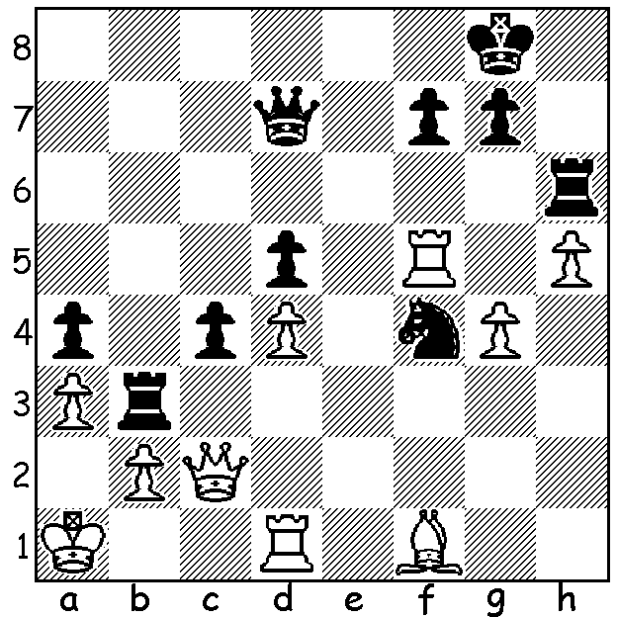

**Pavel Eljanov vs**

**Thai Dai Van Nguyen 2024** *Van Nguyen*

Black to play and win.

**TATA STEEL CHALLENGERS**

This week I’m returning to the **2025 Tata Steel Chess Festival** in Wijk aan Zee played last month where the Masters event was won by **Praggnanandhaa** who beat his compatriot, world champion **Gukesh**, 2-1 in a play-off. While the Masters section gets the lion’s share of media coverage, there are literally hundreds of tournaments and events there catering for thousands of enthusiasts, both professional and amateur. Over the years the Festival has proved a stepping stone for young players in their climb towards the top including world Number 1 and ex-world champion **Magnus Carlsen**. Magnus first played in Corus (name before Tata Steel) C Group, in 2004 coming first aged 13 with 10.5/13. He came 1st= the B Group in 2006 with 9/13. In 2007 in his first appearance in the premier event he came last with 4.5/13 but in 2008 came 1st= with Levon Aronian, scoring 8.5/13. He subsequently won the event another seven times between 2010 and 2023. This year the average age of the **Challengers**, the second main event, was a little over 22 years for the 14 players with the youngest being Faustino Oro (Argentina) at 12, Lu Miaoyi (China), one of four females in the event, aged 14. and Ediz Gurel (Turkey) aged 16. The winner, who qualifies for the 2026 Masters, was **Thai Dai Van Nguyen** (Czech.) aged 23 with 9.5/13. Second was 19-year-old Aydin Suleymanli (Azbek) and third Erwin L’Ami (Netherlands), the oldest player in the event at 39. Last year’s Challengers winner **Max Warmerdam** (Netherlands), now 24 years, finished last this year in the Masters but did defeat world Number 2 Fabiano Caruana (USA) and world Number 4 Arjun Erigaisi (India) in scoring 4.5/13.

**SOLUTION**: 1…c3! 2.Rxf4 cxb+ 3.Kb1 Rc6 and wins (if 4.Qf5 Qc7 – threat 5…Rc1+).