**CHESS** March 15, 2025 David Ellis [ellisd10@bigpond.com](mailto:ellisd10@bigpond.com) 0439798607

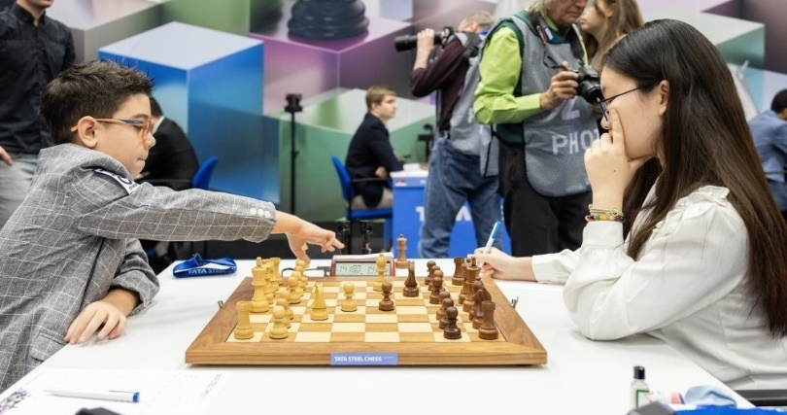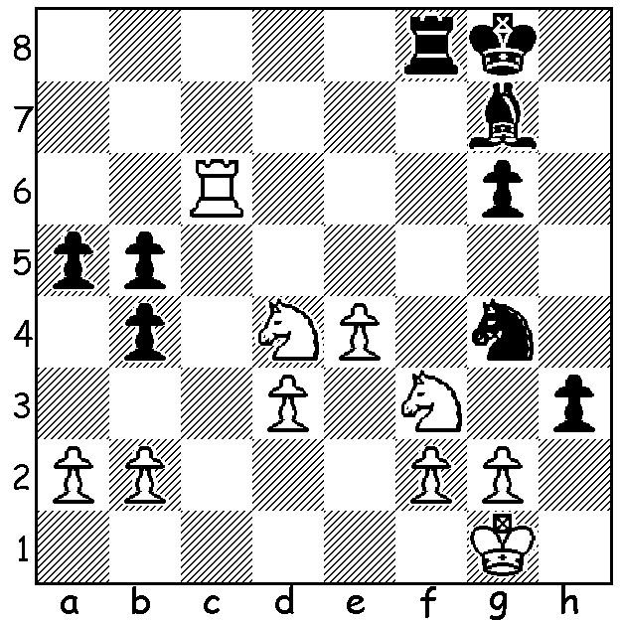

**Faustino Oro vs Lu Miaoyi 2025**

Black plays the tricky 1…h2+.

How does White now win?

**JUNIORS CLASH AT TATA STEEL**

Last week I wrote about the 2025 Challengers Tournament at the Tata Steel Festival, highlighting the inclusion of so many teenage and female players. This week I’m looking at the two youngest contestants at the event with the diagram showing a position from their game.

**Faustino Oro**, born October 2013 in Buenos Aries, Argentina, now lives in Barcelona, Spain where he has a group of five GMs coaching him. He only learnt to play at seven during the covid restrictions. Initially he was shown the moves by his father and then coached by his grandfather Luis Oro, himself an accomplished player. In 2003, aged nine, Faustino became the youngest chess player to achieve a rating of 2300+ in Classic Chess (a record since broken by Ethan Pang from England). In June 2024, aged 10 years and 8 months, he became the youngest to earn the title of IM (International Master), breaking the record of now GM Abhimanyu Mishra (USA). He has defeated both Magnus Carlsen and Hikaru Nakamura in Bullet Chess (less than three minutes for each player). Faustino scored 3.5/14 at Tata Steel.

**Lu Miaoyi**, born February 2010. is an IM with a peak rating of 2449. She is ranked second among Junior Girls to Indian Divya Deshmukh (who also played in the Challengers, scoring 3.5/13). Lu is the reigning Chinese women’s champion and the fourth youngest girl ever to become an IM. She learnt aged three from her mother, a WGM (Women’s Grandmaster), and played her first FIDE rated tournament aged five. When ten she won the Belgrade International Women’s Grandmaster tournament. Lu scored 5.5/13 at Tata Steel.

**SOLUTION**: After 1…h2+ (1…hxg is met by 2.Rxg6) 2.Nxh2! Nxh2. White, now a piece down and his knight attacked, plays 3.Rxg6 preventing 3…Bxd4 and trapping the knight. If now 3…Kh7 4.Rxg7+! Kxg7 5.Ne6+ Kf7. 6.Nxf8 winning). After 3…Rf7 4.Nf5 gave White a simple win.

And did you work out last week’s crossword clue, ‘sounds like an angler and a policeman ousted a champion’? The answer was Bobby (slang for policeman) and Fischer (sounds like fisher) who dethroned world champion Boris Spassky in 1972.