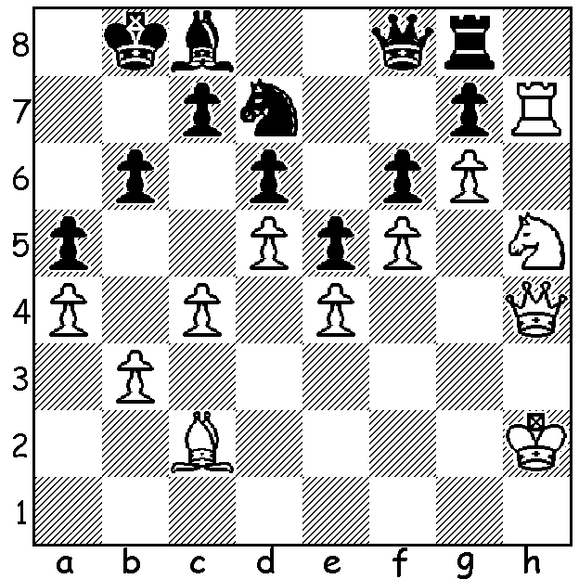**CHESS** March 22, 2025 David Ellis [ellisd10@bigpond.com](mailto:ellisd10@bigpond.com) 0439798607  **A B**

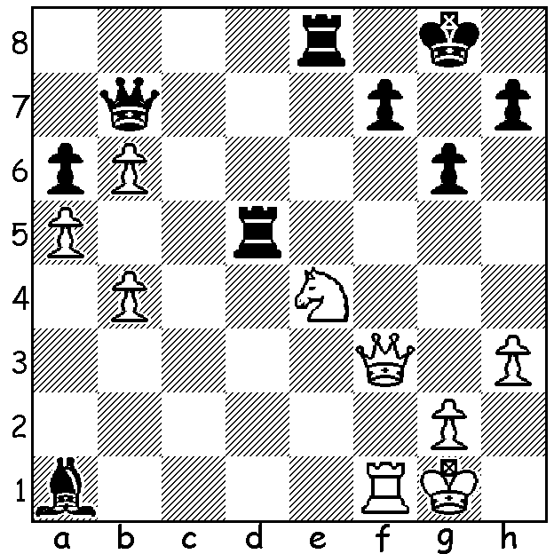

**Rheyansh Annapureddy Cheng Dai**

**vs Cheng Dai vs David Ellis**

(Ballarat 2025, Rd 7) (Ballarat 2025, Rd 2)

White plays 1.Rxa1 and How does White breach

loses. Calculate why and Black’s fortress?

instead find a win for White.

**CHESS AT BALLARAT**

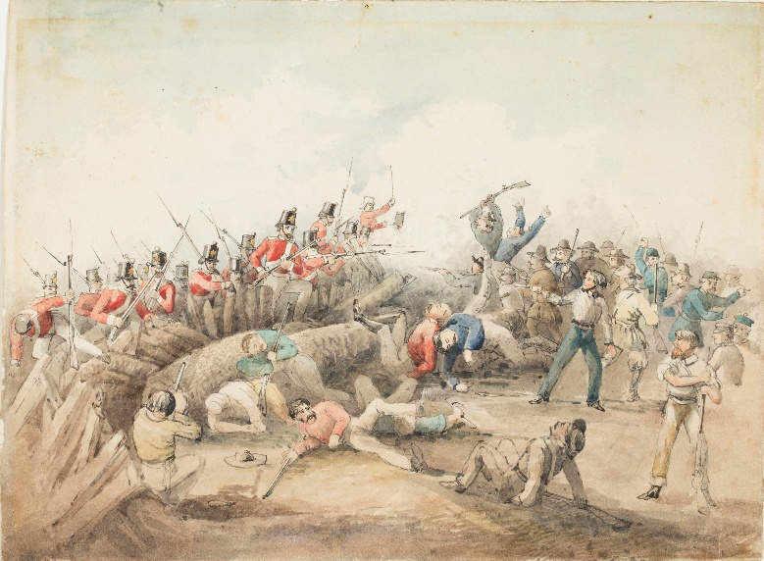I have recently returned from a holiday which included the Kosciuszko National Park in NSW and Lakes Entrance, the Mornington Peninsular and Ballarat in Victoria. Ballarat is famous as the site of the 1854 Eureka Stockade during the gold rush when miners revolted against the British administration of Victoria. The revolt which

resulted in 27 deaths is seen as a significant

step in the development of democracy in

Australia. Each year the city holds a

Begonia Festival over the Victorian Labour

Day long weekend with the Begonia Open

chess tournament being part of the festival.

The tournament, which has been played

annually for over 50 years starting in 1967

with 28 players, is the largest regular

regional chess event in Australia. This year

the event attracted 234 entrants ranging from

unrated primary school children to more

than 30 titled players with the sole GM being

Darryl Johansen, a six times Australian

champion and winner of the event 14 times. Other winners have included Ian Rogers and a number of other Australian champions as well as Nigel Short. The tournament finished with five Victorian players on 6/7 who shared the top prizes, Ari Dale, Israel Yadao, James Morris, Luis Chan and Cheng Dai. My own score of 4.5 (+4 =1 -2, =30th - 60th) was very much par for the course with my two losses being against titled players, one of which was Cheng.

**SOLUTION**: A: An important game for both player as a win would gain a share of first place. 1.Rxa1? loses to 1…Rxe4! 2.Qxe4 Rd1+! winning the queen. Instead White could have played 1.Nd6! with complications continuing with 1…Bd4+ 2.Kh1 Rf5! when 3.Qxf5! gxf5 4.Nxb7 wins but not 3.Qxb7? Rxf1+ 4.Kh2 Bd6+ 5.g3 Bxd6 winning.

B: 1.Nxg7! Rxg7 2.Rxg7 Qxg7 3.Qh7 & queening. Shame on the Black king for running from the kingside and not staying to protect the queen.