CHESS 29 March 2025 David Ellis [ellisd19@bigpond.com](mailto:ellisd19@bigpond.com) 043979860

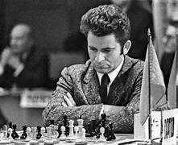 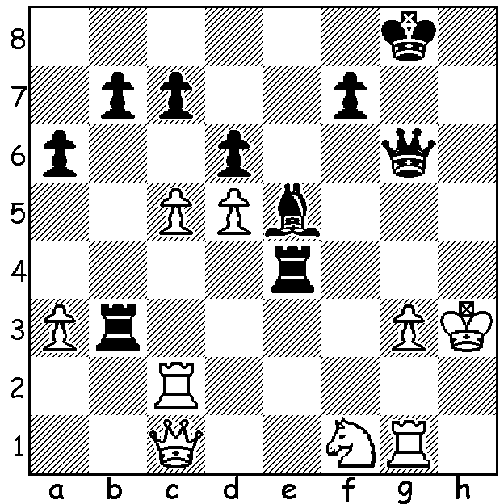

**Staf Somers vs Boris Spassky:**

Black mates in 7. *Boris Spassky*

**BORIS SPASSKY (I)**

While on holiday I heard that former world champion Boris Spassky had died in Moscow on 27th February aged 88. Born 30 Jan 1937 in Leningrad (now St Petersburg) he learnt to play chess at the age of 5 years while on a train escaping from the German attack on the city. He was then sent to an orphanage in Siberia away from the conflict. He showed considerable promise and at the age of ten years he defeated the Soviet and world champion-to-be Mikhail Botvinnik in a simultaneous exhibition in Leningrad. At the age of 15 he gained second place in the Leningrad Championship. In 1955, at his first attempt, he tied for 3rd with 11.5/19 in the Soviet Championship and in the same year he won the World Junior Championship in Antwerp, Belgium, scoring 8/9. In 1956 he qualified for the Candidates and was awarded his Grandmaster title, the youngest at the time to gain the title. In the Candidates in Amsterdam he came =3rd /10 with 9.5/18. In 1956 he also came =1st in the Soviet Championship, losing to Mark Taimanov in a playoff. After a slump in performances during which he and his first wife divorced, he broke with his coach Alexander Tolush, a renowned attacking player, instead gaining the services of Igor Bondarevsky, a more accomplished and all-round player. His performances improved including winning the Soviet Championship in 1961 (the first of four) and =1st with Bobby Fischer at Mar del Plata scoring 13.5/15. In 1965 he won the Candidates in Riga beating Paul Keres in the quarterfinal, 6-4, Efim Geller 5.5-2.5 in the semi and former world champion Mikhail Tal 7-4 in the final. (Candidate tournaments had changed to knockout after complaints from some players, particularly Bobby Fischer.) Spassky was now with an opportunity to become world champion in a 24-game match against Tigran Petrosian who had won the title from Botvinnik.

**SOLUTION:** 1…Rh4+! 2.Kxh4 Qh7+ 3.Kg5 f6+ 4.Kg4 f5+ 5.Kg5 Kg7! 6.Rh2 Qg6+ 7.Kh4 Qg4#.