CHESS 4 April 2025 David Ellis [ellisd19@bigpond.com](mailto:ellisd19@bigpond.com) 043979860

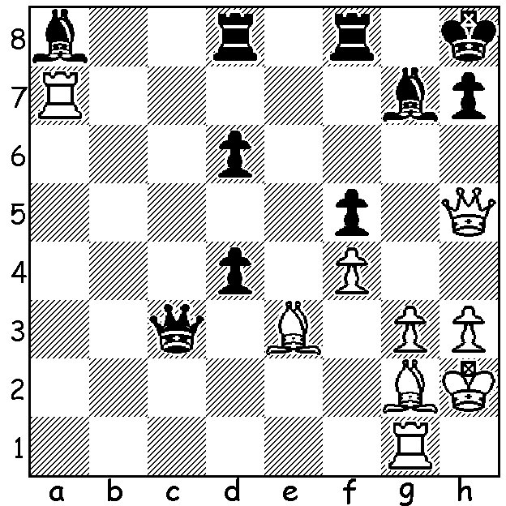

**Boris Spassky vs**

**Aivars Giplis 1961**

Brilliant sacrifices

lead to a White mate.

**BORIS SPASSKY – MATCHES WITH PETROSIAN**

Last week we left Boris Spassky in 1966 about to take on world champion Tigran Petrosian in a 24-game match in Moscow. Petrosian had earned the nickname ‘Iron Tigran’, given the difficulty of beating him. The match began cautiously with six successive draws before Petrosian won Games 7 & 10. Spassky succeeded in drawing level with wins in Games 14 & 19 but lost Games 20 & 22

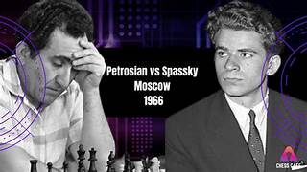giving the champion victory by 12-10 (+4 =16 -2). This was the first match win by a defending champion since 1934 when Alexander Alekhine

defeated Efim Bogoljubov 15.5-10.5.

Undeterred by his loss Spassky again went

through a gruelling Candidates Knockout in

1968 to qualify a second time for a chance

to unseat Petrosian with wins against Efim

Geller 5.5-2.5 in the quarter final, Bent Larsen

5.5-2.5 in the semi and Viktor Korchnoi 6.5-3.5

in the final.

Spassky was not only better prepared a second

time but with many recent tournament successes

behind him was much more confident. The 1969 match proved a more lively struggle with 10 decisive games. Although he lost Game 1, wins in Games 4,5 & 8 gave him a two point lead before Petrosian won Games 10 & 11 to drew level. Spassky regained the lead with wins in Games 17 & 19 and won Game 21 after Petrosian had once more threatened a comeback winning Game 20. Two draws concluded the match with victory to Spassky 12.5-10.5 (+6 =13 -4), thus becoming the 10th world champion.

After the match Spassky said, ”In the first match I flung myself at Petrosian like a kitten attacking a tiger and it was easy for him to parry my blows. But by the second I’d matured to a bear … (and) I held him in a grip.”

**SOLUTION:** 1.Rxg7! Kxg7 2.Rc1!! & if 2…Qxc1 3.Bxd4+ Kg8 4.Qg5+ Kf7 5.Qf6+ Ke8 6.Qe6#: if 2…Qxe3 3.Rc7 mates,