CHESS 12 April 2025 David Ellis [ellisd19@bigpond.com](mailto:ellisd19@bigpond.com) 043979860

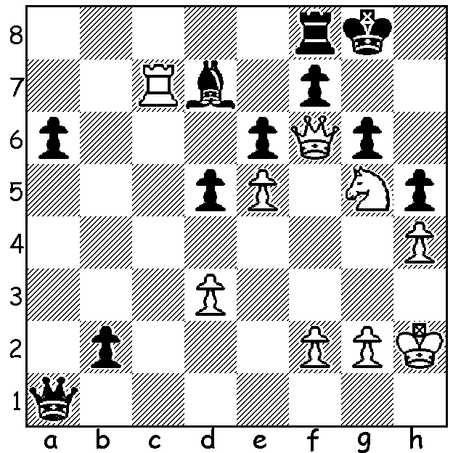

**Boris Spassky vs**

**Edmar Mednis 1961**

White to play and win.

**BORIS SPASSKY – MATCH of the CENTURY**

After defeating Tigran Petrosian in their world championship match 12.5-10.5 in 1969, Boris Spassky was faced with the challenge of Bobby Fischer in 1972. The Russians had prepared for this with almost all the top players working to assist Spassky in his preparation while Fischer

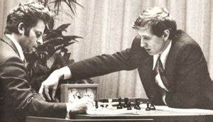virtually prepared on his own. The match was

played in Reykjavik, Iceland, in 1972 with

Spassky’s confidence bolstered by his record

against Fischer, 3 wins & 2 draws in their 5

previous games despite Fischer’s appreciable

rating plus over Spassky and his crushing of

the Russian Mark Taimanov and ‘The Great

Dane’ Bent Larsen, both 6-0 in Candidate

matches. However despite gaining a 2-0 lead

(the second win on forfeit) Spassky was no

match for the young American, losing 8.5-12.5 *Spassky (White) vs Fischer 1972*

(+3 =11 -7). While he was soundly beaten Spassky proved to be a true sporting gentleman, declining the Russian order to claim the match when Fischer failed to attend the opening ceremony, tolerating Fischer’s repeated demands to change the playing conditions and even joining in the applause after one of Fischer’s wins.

In 1992 Spassky again took on Fischer, who came out of retirement to play, and again he was well beaten, 12.5-17.5. The match, with the prize money of $5million with winner receiving $3.5million, was played in Yugoslavia which was under UN sports sanctions because of the civil war there.

When USA issued a warrant for Fischer’s arrest, Spassky wrote to President Bush requesting

’mercy, charity’ for Fischer and if this was not forthcoming he offered to share a cell with Fischer as he had committed the same crime (and they be given a chess set while incarcerated).

Another quote from Spassky: ‘when you play Bobby, it is not a question if you win or lose, it is question if you survive’.

Next week Spassky leaves Russia for France.

**SOLUTION:** 1.Rxd7! (ignoring the Black promotion) 1…b1=Q 2.Nxe6! ; if 2…fxe6 3.Qg7#.: if 2… Qh1+ 3.Kg3 and the only checks left lose one of the queens with Black still unable to avoid mate. .