**CHESS** ch 25 05 28 (Miles 2) David Ellis [ellisd19@bigpond.com](mailto:ellisd19@bigpond.com) 0439798607

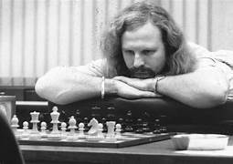 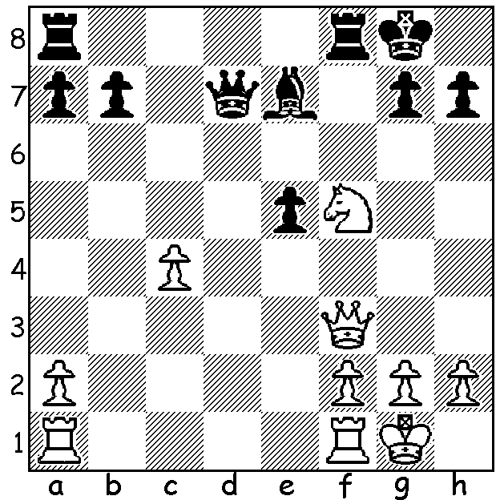

**Tony Miles vs Jan Timman1985:** *At 1985 Tilburg Tournament Miles tied for**first place*

White to play and win (3 moves): *with Hubner & Korchnoi. Suffering from a* *bad back*

*he played a number of games lying on his stomach.*

**FIRST ENGLISH GRANDMASTER**

Last week we read about chess on BBC TV, Chess Masters, between 1975 and 1983 with mention of Tony Miles, the first over-the board English-born Grandmaster. Born in 1955 in Birmingham, Miles showed talent at an early age, winning the British Under-14 and the Under-21 title twice. In 1973 he was runner-op at the World Junior Championships and took the title the following year. In 1976 he earned £5000 (a prize offered by chess-loving businessman Jim Slater) for becoming the first British GM, narrowly ahead of Raymond Keene. During his career he defeated ex-world champions Vasily Smyslov, Mikhail Tal and Boris Spassky and reached number 9 in world rankings. At the 1980 European Team Championship he defeated world champion Anatoly Karpov, meeting 1.e4 with 1…a6 (called the St George Defence as the victory came on St Georges Day, April 23). He also defeated Karpov in the final BBC TV Chess Masters series. He won the British Championship once, in 1982. Playing Board 1 he helped England to silver medals at both the 1984 and 1986 Olympiads. In 1984 he set a European record in Blind Simultaneous Chess, taking on 22 opponents at once (+10 =10 -2). He began to suffer mental problems stemming from a festering

disagreement with Keene, was arrested and hospitalised for two months in 1987 and moved temporarily to USA with his last tournament success being the 2001 Canadian Championship (he also visited and played in Australia). A diabetic, he died in 2001 of heart failure with his body discovered at his home in Birmingham.

**SOLUTION**: 1.Qd5+! Qxd5 2.Nxe7+ Kh8 3.Nxd5.