CHESS Sept5, 2026 David Ellis ellisd19@bigpond.com 0439798607

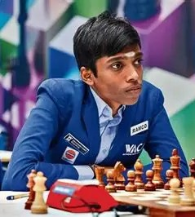
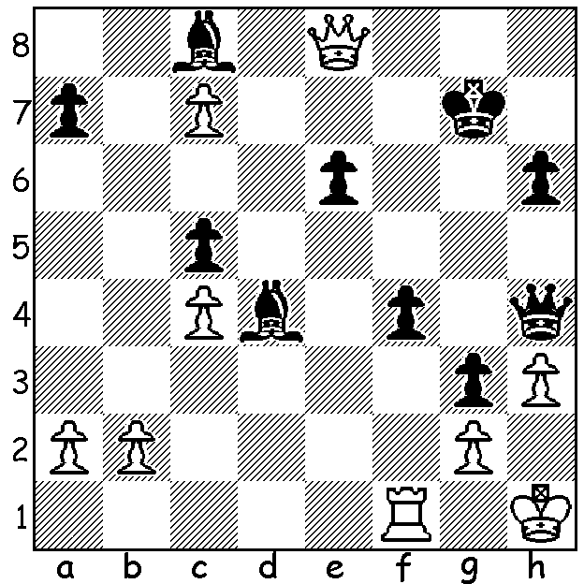

David Anton vs Praggnanandhaa Pragg
Rameshbabu 2021: how does Black win?

MORE ELECTION NEWS
The West has recently been full of news and reports of the Secret Harbour by-election and I’m continuing the election theme, not with talk about Australian politics but a forthcoming vote which will decide the direction of FIDE (the International Chess Federation) for years to come. In June this year the then Russian president of FIDE, Arkady Dvorkovich, voluntarily suspended his powers and duties following the European Union’s placing him on the Union’s sanction list relating to the invasion of Ukraine. His position was taken on by ex-world champion Vishy Anand until a new president is elected at the Chess Olympiad (15-27 Sept in Uzbekistan) when voting will elect one of the three candidates. All affiliated countries will have one vote whether they be China, India or the USA or a small island state with a mere handful of registered players. Over the years the presidency has been won either by millionaires who are prepared to funnel vast amounts into the game or men with connections to big industry who can obtain generous sponsorship. The three candidates are Jan Henric Buettner, Timur Turlov and Wadim Rosenstein. Next week I shall write about theses three men and their visions for Chess in the future as well as the various claims and accusations of all three candidates in what is proving to be a very intense and bitter contest.



SOLUTION: 1…Qxh3+!! 2.gxh3 Bb7+ 3.Qc6 Bxc6+ 4.Rf3 Bxf3#.

MY UNREMARKABLE CHESS CAREER – Year 11, 1964

1964 marked the beginning of a period of regular tournament wins which was to extend into the 1970s. The game below sees me starting on the road to winning the Kent Championship in 1965.

D Ellis – G P Robinson
Kent Championship, Rd 1, 3rd Replay
Grunfeld Defence
1.e3 g6 2.d4 Bg7 3.c4 Nf6
4.Nc3 d5 5.Nf3 0-0 6.Be2 c6
7.0-0 Nbd7 8.b3 dxc 9.bxc c5
10.Bb2 cxd 11.exd b6 12.Qc2 Bb7
13.Rfd1 Rc8 14.Qa4 Bc6 15.Qb3 Ne4
16.d5 Nxc3 17.Bxc3 Ba4 18.Qxa4 Bxc3
19.Rac1 Ba5 20.Nd4 Nc5 21.Qa3 Qc7
22.Nc6 Rfe8 23.Qh3 Ne4 24.Rd4 Qf4
25.Qe3 Qxe3 26.fxe3 Bd2 27.Rxe4 Bxc1
28.Nxe7+ Kf8 29.d6 Rcd8 30.c5! bxc
31.Bb5 Rxd6 32.Bxe8 Rd1+! 33.Kf2 Kxe8
34.Nc6+ Kd7 35.Ne5+ Kc7 36.Ra4 Kb7
37.Nxf7 Rd3 38.e4 Rd7 39.Ne5 Rd2+
40.Kf3 Rd8 41.Rxa7+! Kxa7 42.Nc6+ Kb6
43.Nxd8 c4 44.Ke2 Kb5 45.Kd1 Ba3
46.Kc2 Bb4 47.Ne6 Kc6 48.Ng5 h6
49.Nf3 Kd6 50.g4 h5 51.g5 Ke6
52.a4 Ba5 53.Nd2 c3 54.Nf3 Kd6
55.Kd3 Kc5 56.Ne5 Bd8 57.a4 Kb4
58.Kc2 Kxa4 59.Kxc3 Ba5+ 60.Kc4 Be1
61.Nxg6 resigns

